1. **Clase publice si non publice**

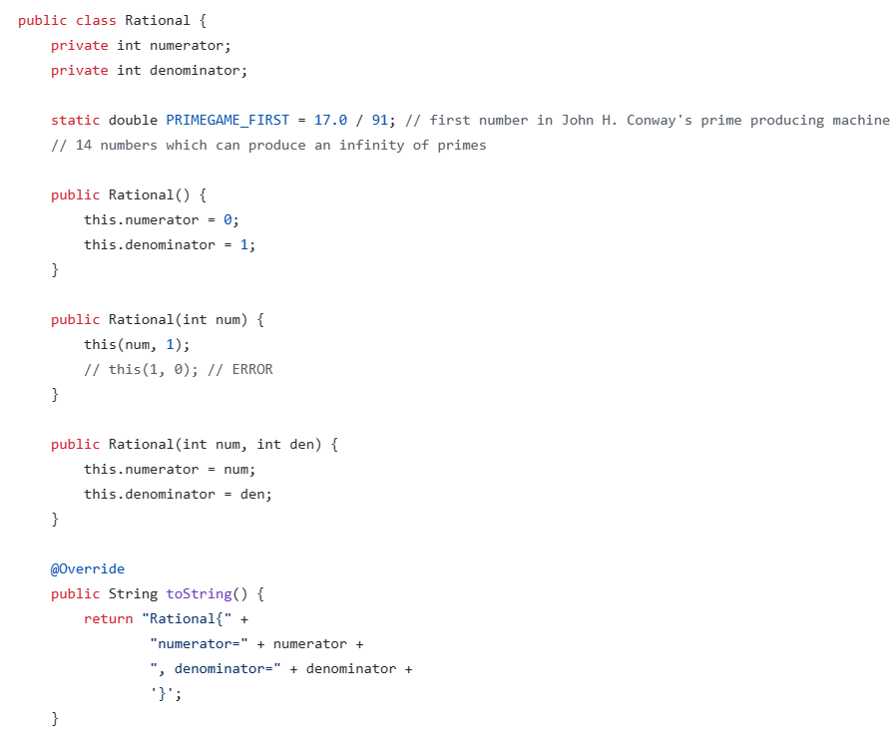

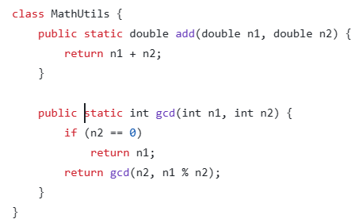



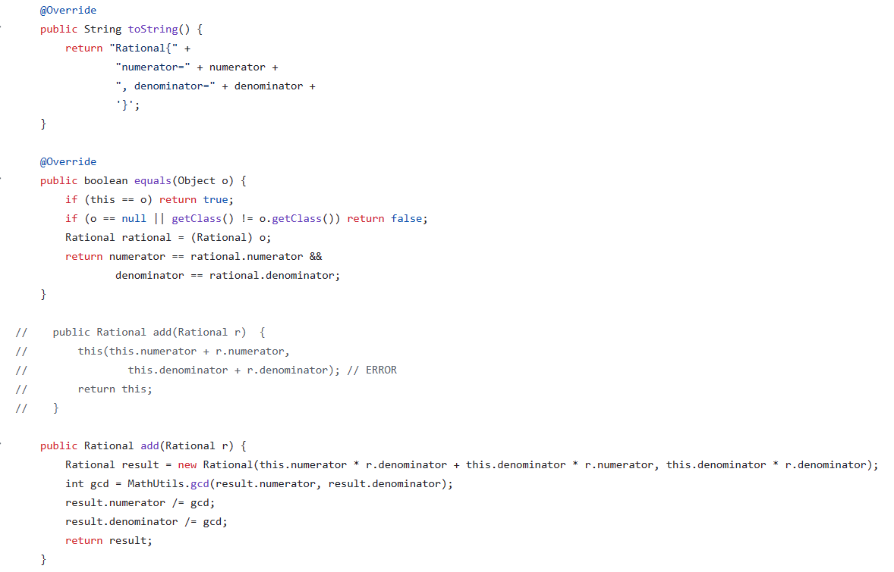



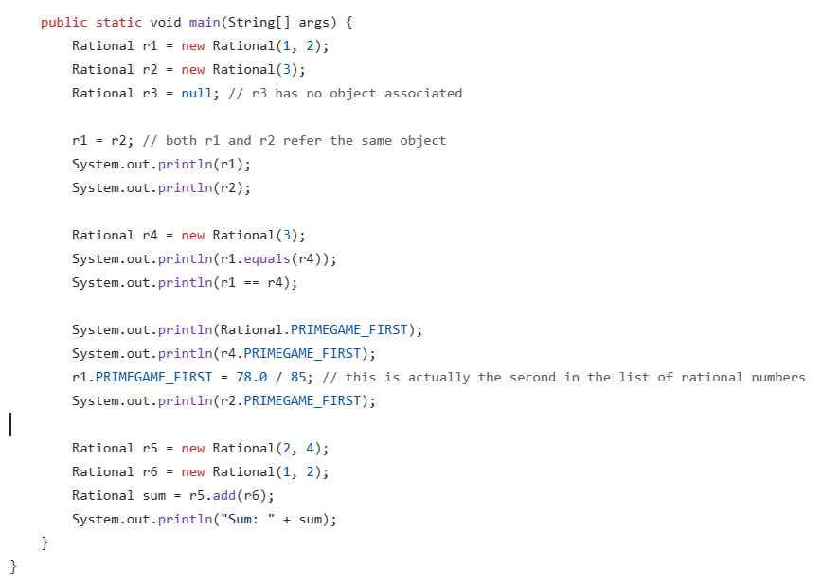

1. 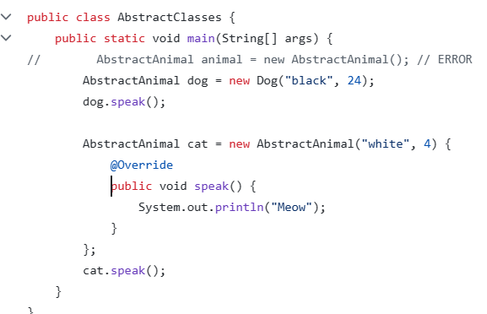Clase abstracte

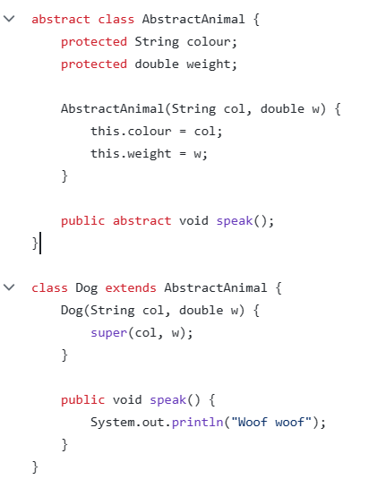

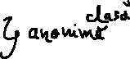

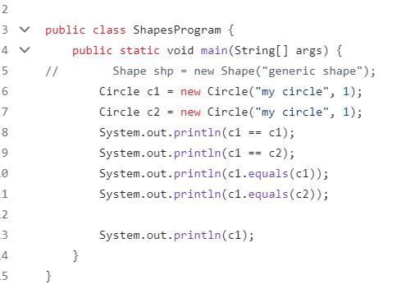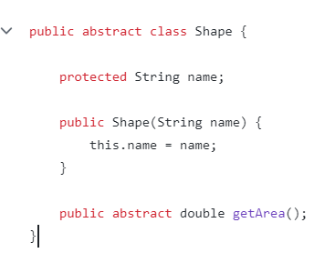 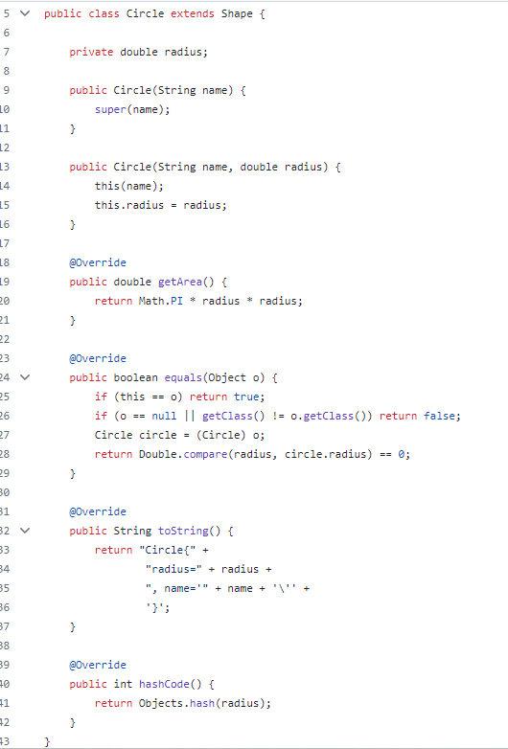



1. Clase imbricate/nested

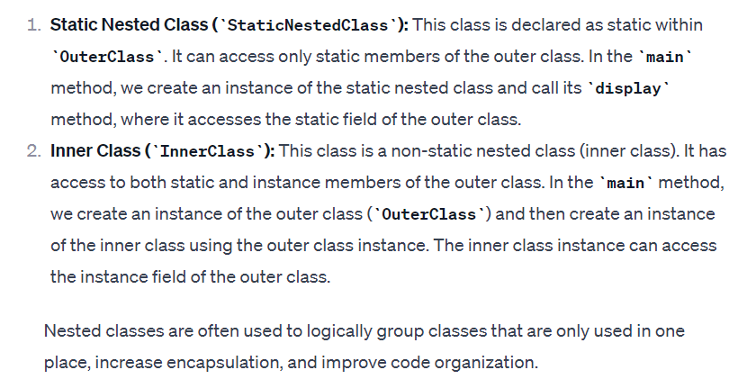

1. Clase anonime

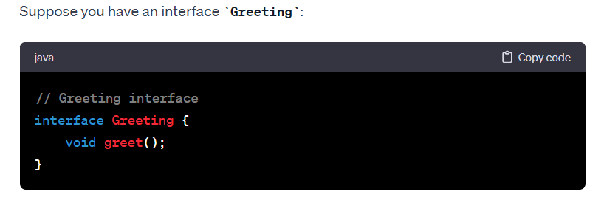



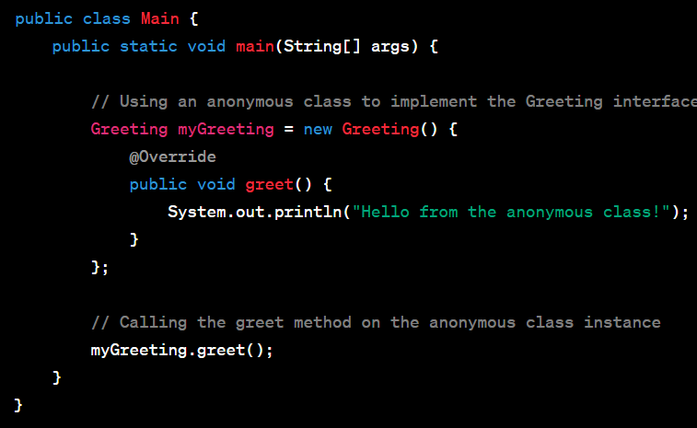

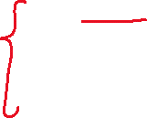

4’. Comparatori

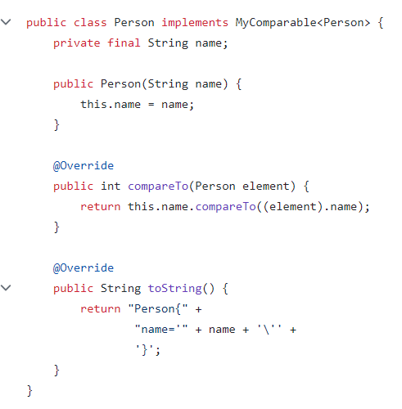

1. Mostenire

-toate clasele sunt moștenite din java.lang.Object

-o clasă poate implementa oricâte interfețe

The **final** keyword ensures that the variable's value cannot be changed after initialization.

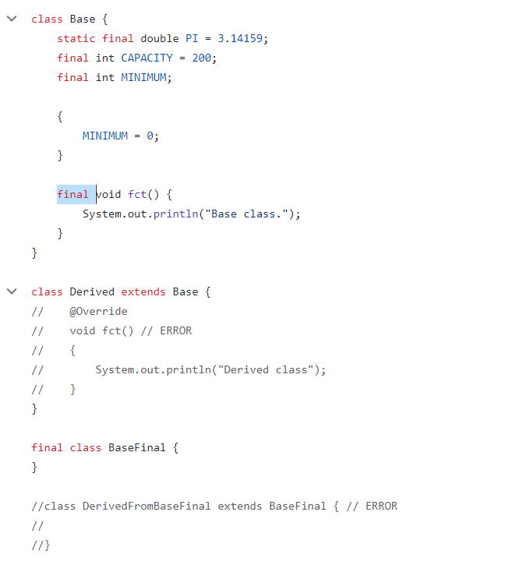 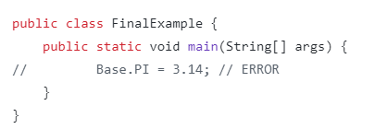



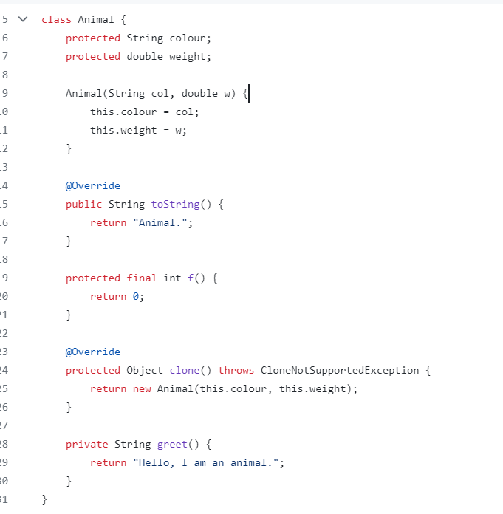 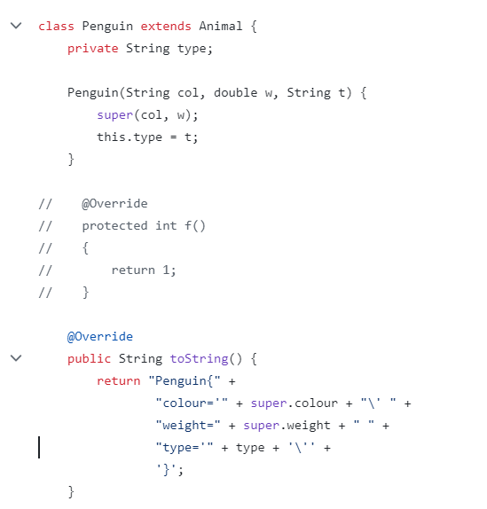

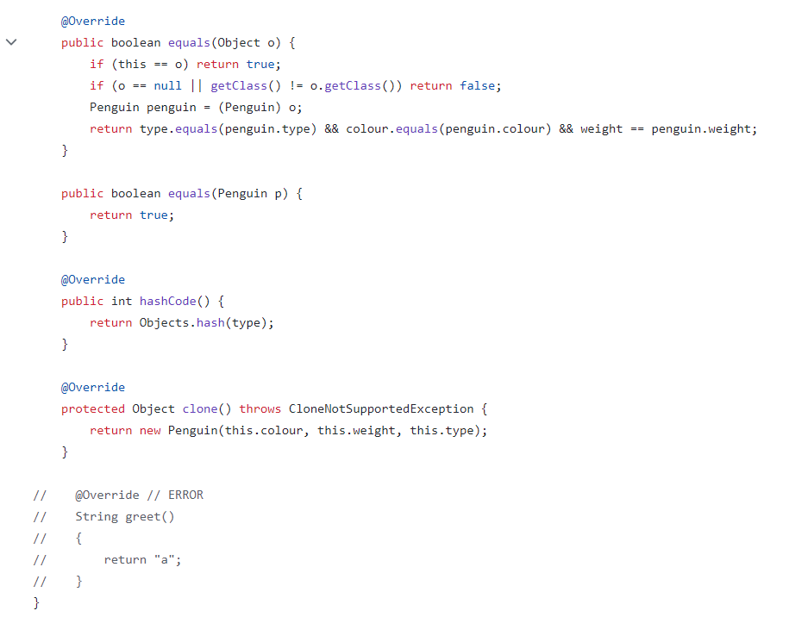 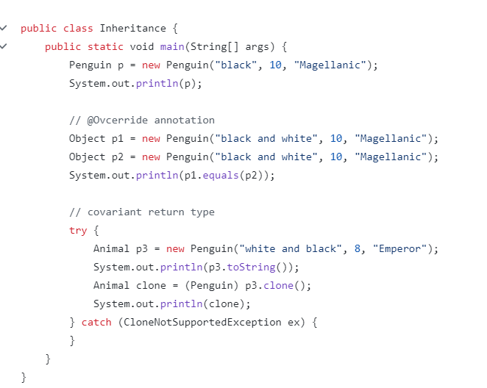

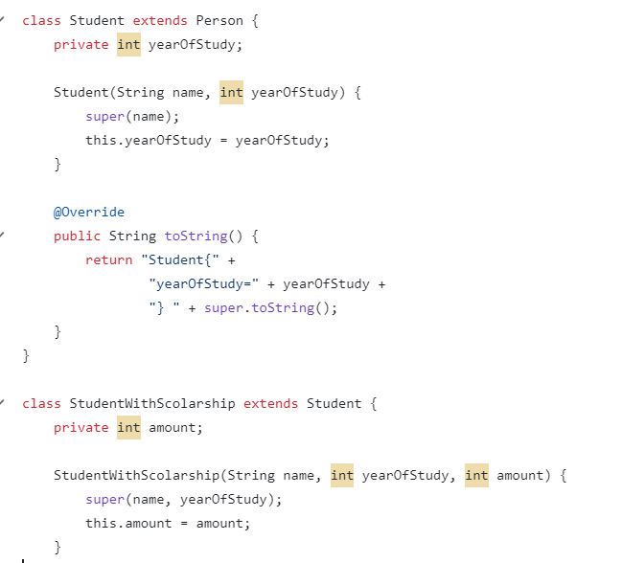

Colectii

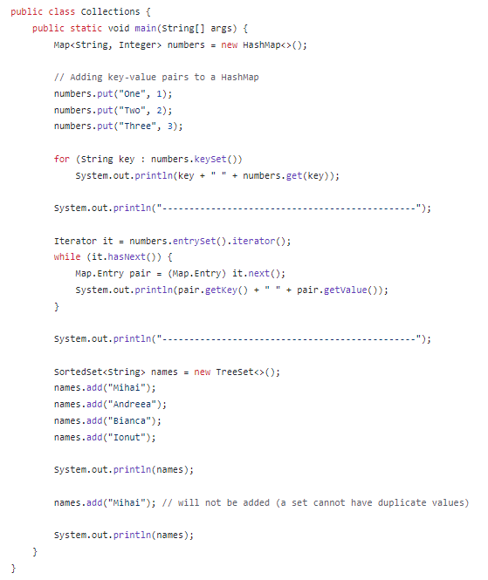

11. Metode statice si non stadice

12. Variabile / metode:

-final,

-static,

-transient,

-synchronized

Interfete – toate metodele sunt publice in interfete

Pachete

- IMPLEMENTS

- EXTENDS

Incapsulare:

-private,

-default,

-protected,

-public

Polimorfism

- aproape toate metodele în Java sunt virtuale

Diagrame UML:

Diagramele UML de clase (definirea unei clase și a unei interfețe, metode abstracte, reprezentarea relațiilor de moștenire și asociere între clase), implementarea unei diagrame de clase UML sub formă de cod Java.

**EXCEPTII**

**clasele Exception RuntimeException**

**checked exceptions** – IO / compile Time exception

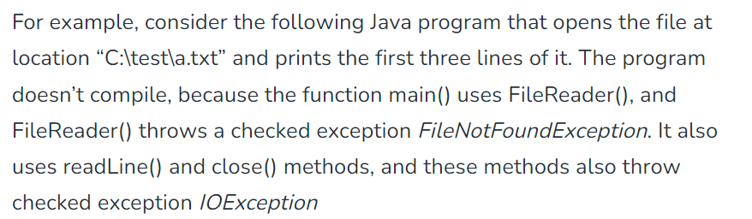

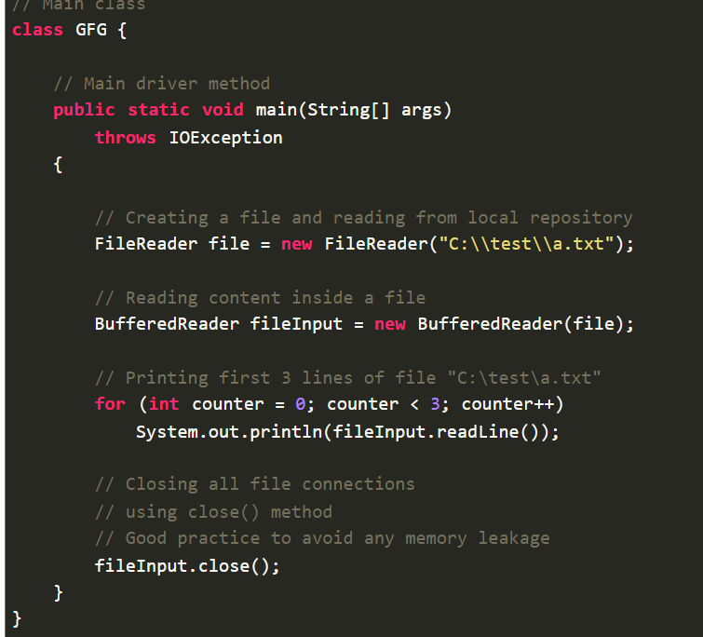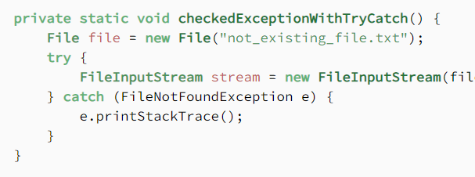

**unchecked exceptions** – Runtime Exception / Null pointer Exception / arithmetic/nfe/index out of bounds

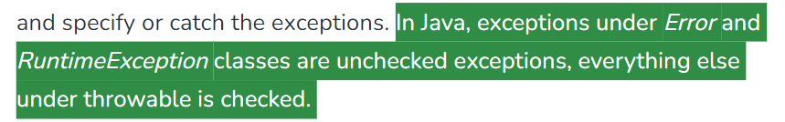

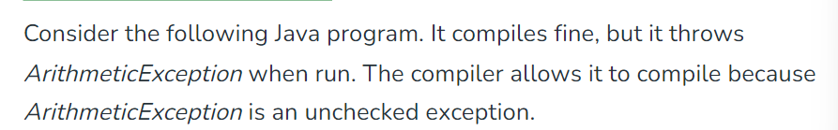

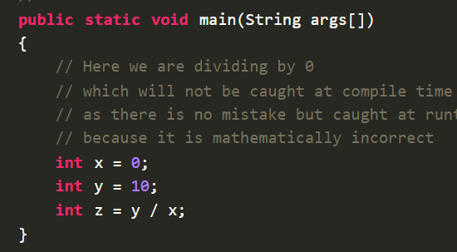

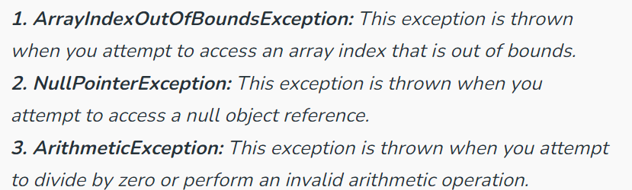

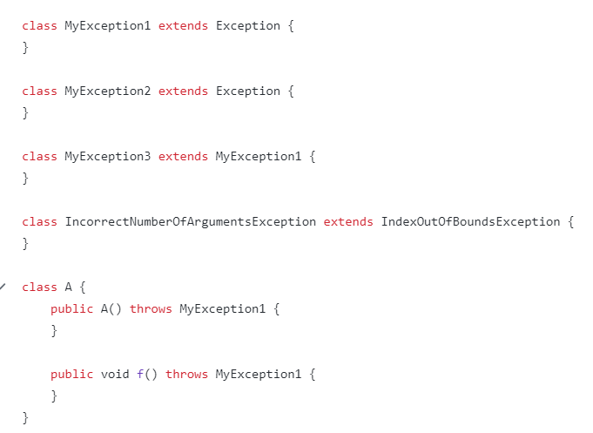

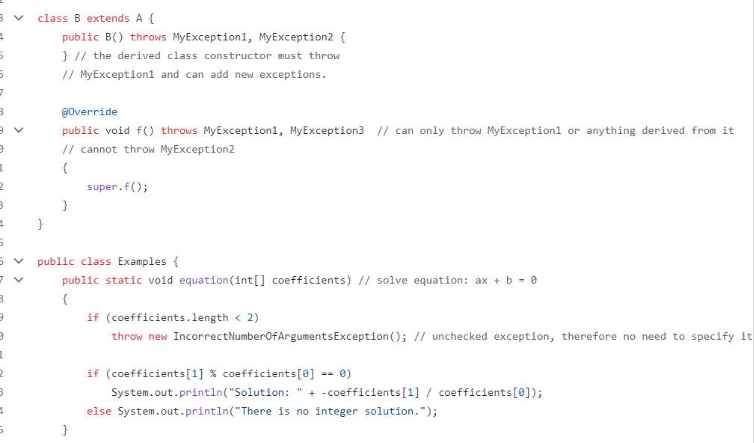

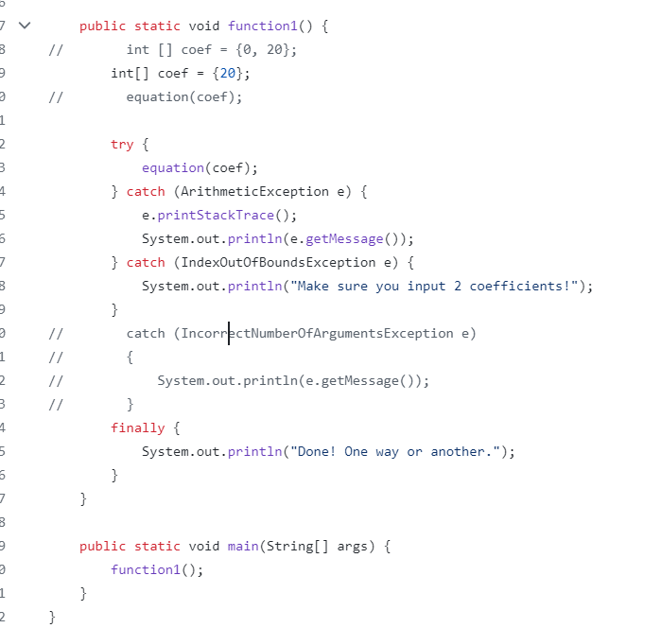

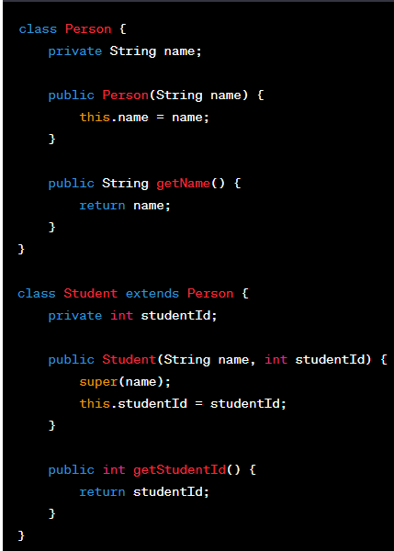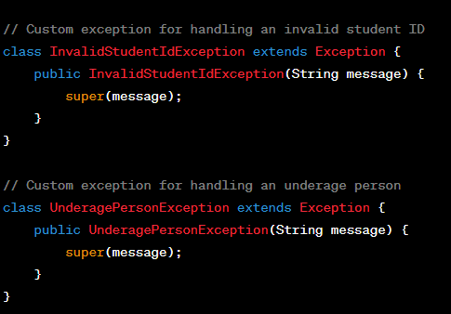

public class CustomExceptionsExample {

// Example method that may throw the custom exceptions

public static void processStudent(Student student) throws InvalidStudentIdException, UnderagePersonException {

if (student.getStudentId() <= 0) {

throw new InvalidStudentIdException("Invalid student ID: " + student.getStudentId());

}

if (student instanceof Person && ((Person) student).getName().equals("John")) {

throw new UnderagePersonException("Underage person detected: " + ((Person) student).getName());

}

// Your logic here

}

public static void main(String[] args) {

try {

// Example usage

Student validStudent = new Student("Alice", 123);

processStudent(validStudent);

// Uncomment the lines below to see how exceptions are handled

// Student invalidStudent = new Student("John", -1);

// processStudent(invalidStudent);

} catch (InvalidStudentIdException | UnderagePersonException e) {

System.out.println("Exception caught: " + e.getMessage());

}

}

}

//

class PersonNotFoundException extends RuntimeException {

public PersonNotFoundException(String message) {

super(message);

}

}

class Student extends Person {

private int studentId;

public Student(String name, int studentId) {

super(name);

this.studentId = studentId;

}

public int getStudentId() {

return studentId;

}

}

public class InheritanceAndExceptionHandling {

public static void main(String[] args) {

try {

// Exemplu de utilizare

searchPersonById(123);

} catch (PersonNotFoundException e) {

System.out.println("Person not found: " + e.getMessage());

} catch (Exception e) {

System.out.println("An unexpected error occurred: " + e.getMessage());

} finally {

System.out.println("Finally block executed.");

}

}

// Metoda care aruncă o excepție specifică de tip PersonNotFoundException

public static void searchPersonById(int personId) throws PersonNotFoundException {

// Logica de căutare a persoanei

// În acest exemplu, aruncăm excepția PersonNotFoundException pentru ilustrare

throw new PersonNotFoundException("Person with ID " + personId + " not found.");

}

}

**IO**

Lucrul cu fișiere text (clasele *Reader și *Writer), clasele de buffer (ex. BufferedReader) • Lucrul cu fișiere binare (clasele *Stream) și serializarea Java (ObjectInputStream, ObjectOutputStream), interfața Serializable, câmpul de versiune al clasei serializate, cuvântul transient.

**Fisiere**

**- text**

**clasele *Reader și *Writer**

**clasele de buffer (ex. BufferedReader)**

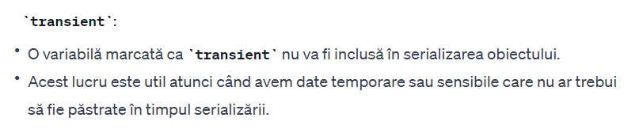

import java.io.*;

class TransientVariableExample implements Serializable {

transient int sensitiveData = 42;

String nonTransientData = "This is not transient";

public static void main(String[] args) throws IOException, ClassNotFoundException {

TransientVariableExample obj = new TransientVariableExample();

// Serializare

try (ObjectOutputStream out = new ObjectOutputStream(new FileOutputStream("object.ser"))) {

out.writeObject(obj);

}

// Deserializare

try (ObjectInputStream in = new ObjectInputStream(new FileInputStream("object.ser"))) {

TransientVariableExample deserializedObj = (TransientVariableExample) in.readObject();

System.out.println("Sensitive Data: " + deserializedObj.sensitiveData); // Output: 0 (default value)

System.out.println("Non-Transient Data: " + deserializedObj.nonTransientData); // Output: This is not transient

}

}

}

**- binare**

**(clasele *Stream)**

**serializarea Java (ObjectInputStream,**

**ObjectOutputStream), interfața Serializable, câmpul de versiune al clasei serializate, cuvântul transient.**

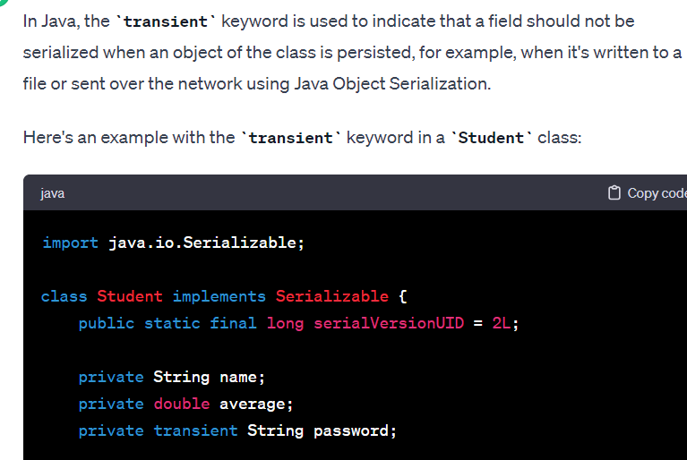 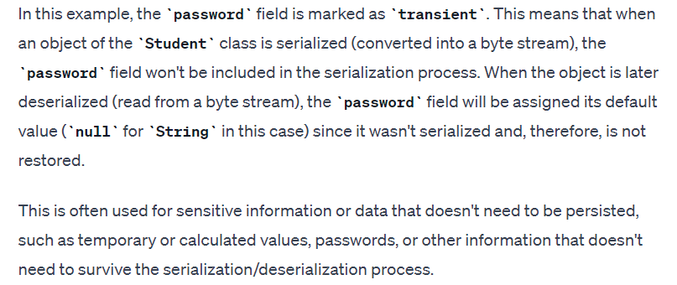

**import java.io.*;**

**class Employee implements Serializable {**

**private static final long serialVersionUID = 1L;**

**private String name;**

**private int age;**

**private transient String temporaryData;**

**public Employee(String name, int age, String temporaryData) {**

**this.name = name;**

**this.age = age;**

**this.temporaryData = temporaryData;**

**}**

**@Override**

**public String toString() {**

**return "Employee{" +**

**"name='" + name + '\'' +**

**", age=" + age +**

**", temporaryData='" + temporaryData + '\'' +**

**'}';**

**}**

**}**

**public class TransientExample {**

**public static void main(String[] args) {**

**// Create an instance of Employee**

**Employee employee = new Employee("John", 30, "Temporary Data");**

**// Serialize the object to a file**

**serializeEmployee(employee, "employee.ser");**

**// Deserialize the object from the file**

**Employee deserializedEmployee = deserializeEmployee("employee.ser");**

**// Display the deserialized object**

**System.out.println(deserializedEmployee);**

**}**

**private static void serializeEmployee(Employee employee, String fileName) {**

**try (ObjectOutputStream oos = new ObjectOutputStream(new FileOutputStream(fileName))) {**

**oos.writeObject(employee);**

**System.out.println("Employee object has been serialized");**

**} catch (IOException e) {**

**e.printStackTrace();**

**}**

**}**

**private static Employee deserializeEmployee(String fileName) {**

**try (ObjectInputStream ois = new ObjectInputStream(new FileInputStream(fileName))) {**

**return (Employee) ois.readObject();**

**} catch (IOException | ClassNotFoundException e) {**

**e.printStackTrace();**

**return null;**

**}**

**}**

**}**

**Fisiere text**

* **Citire**
* **Scriere**

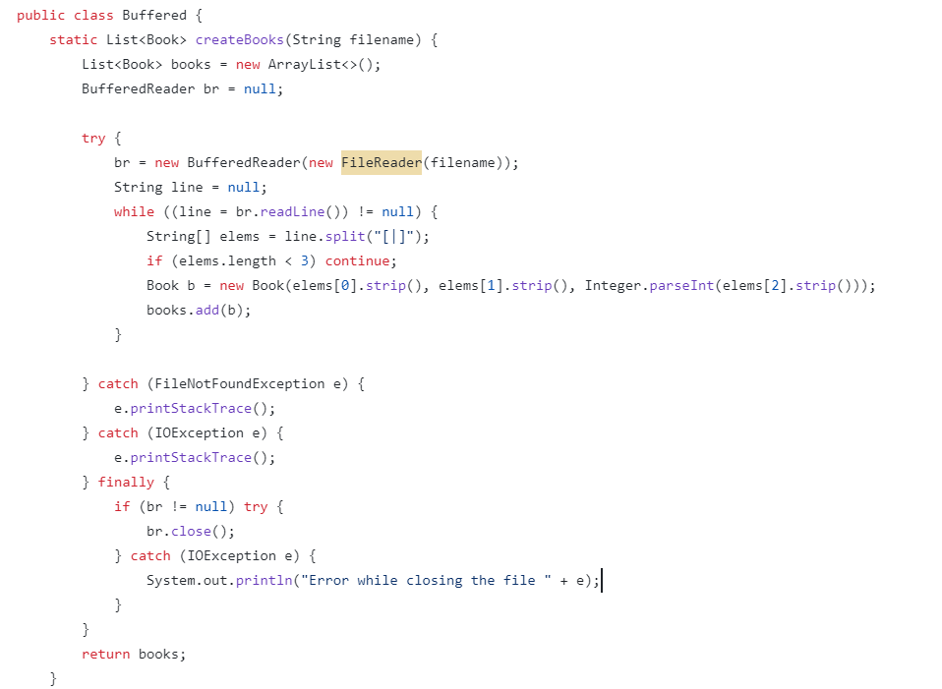

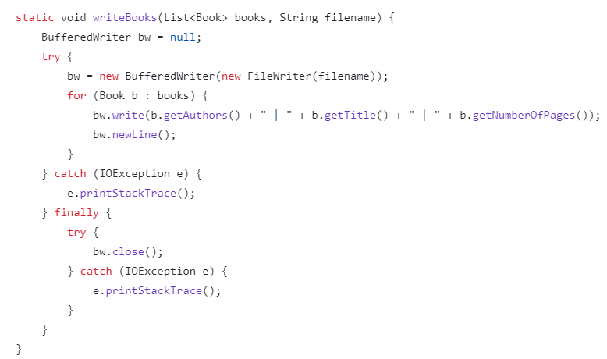

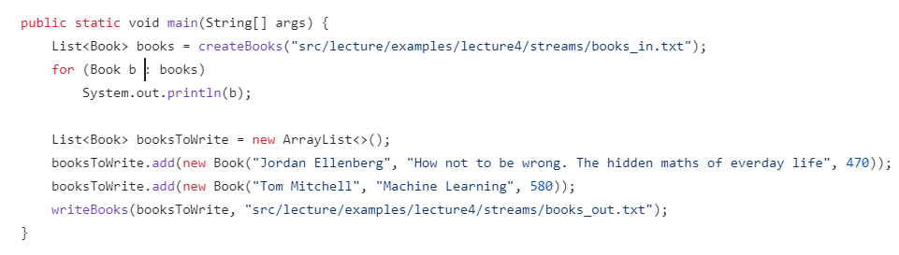

**books_in.txt**

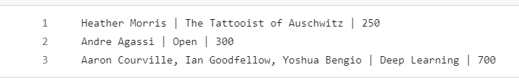

**books_out.txt**



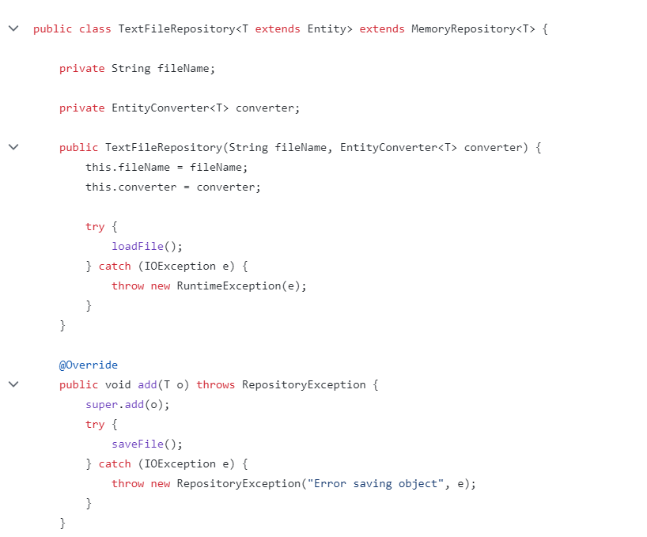

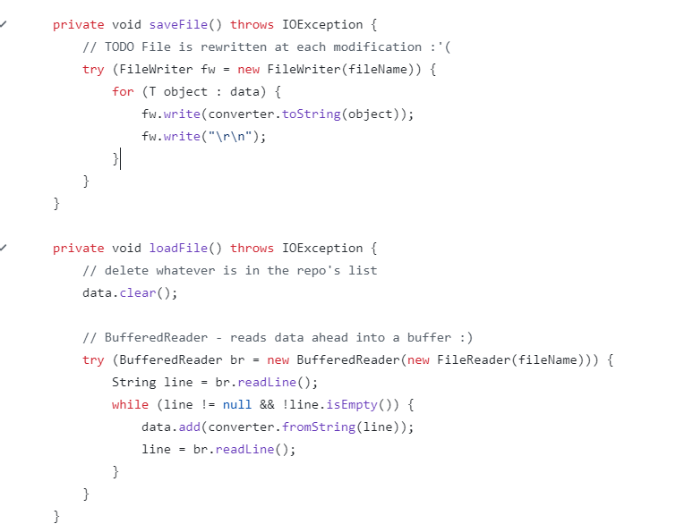

**Fisiere binare**

* **Citire**
* **Scriere**
* **File1.txt**
* 
* **File2.txt**
* 

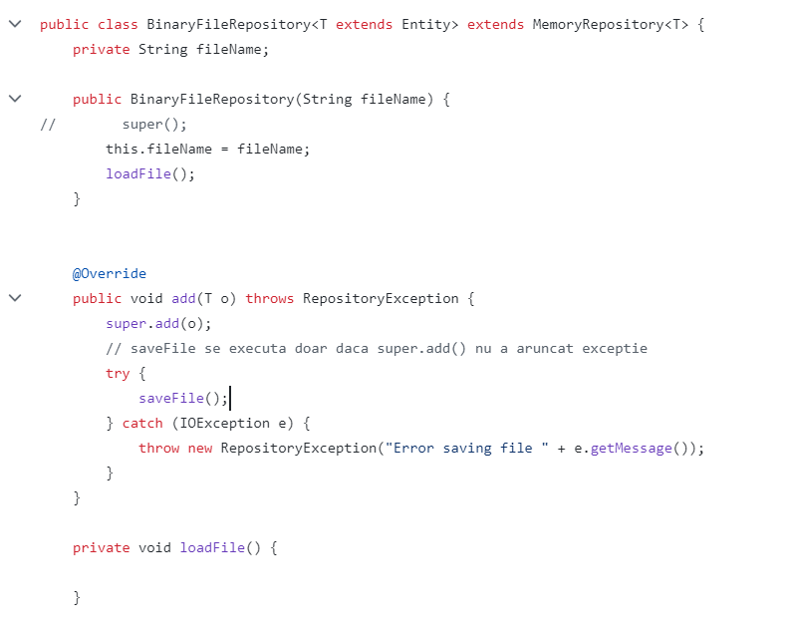

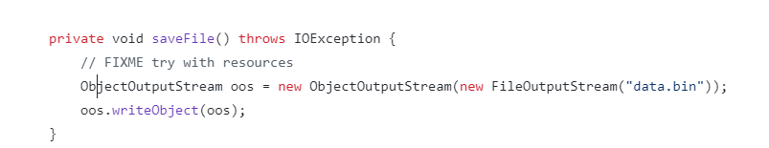

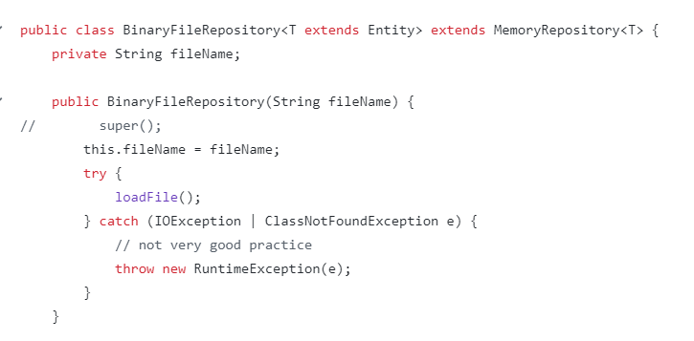

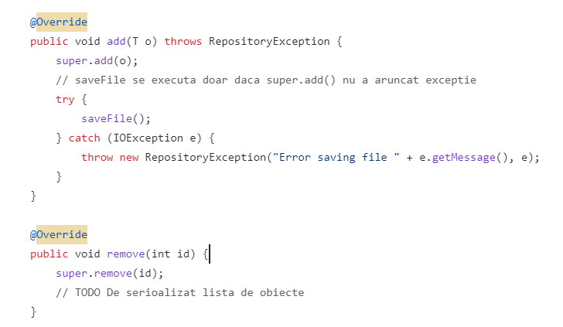

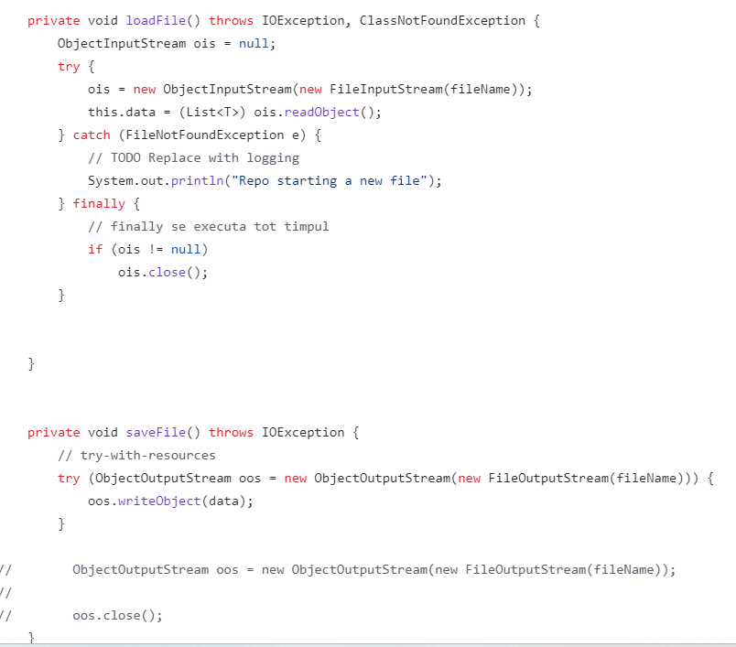

**Clasa settings // Citire din settings.properties**

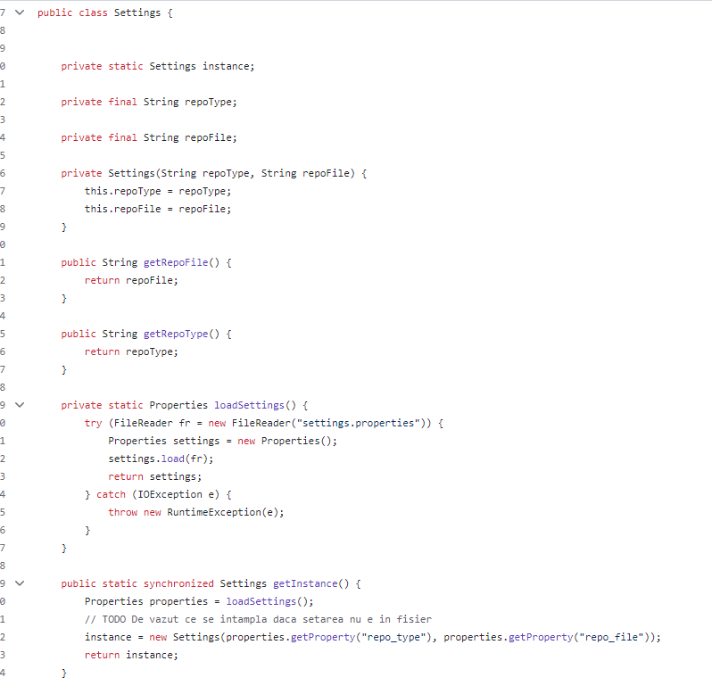

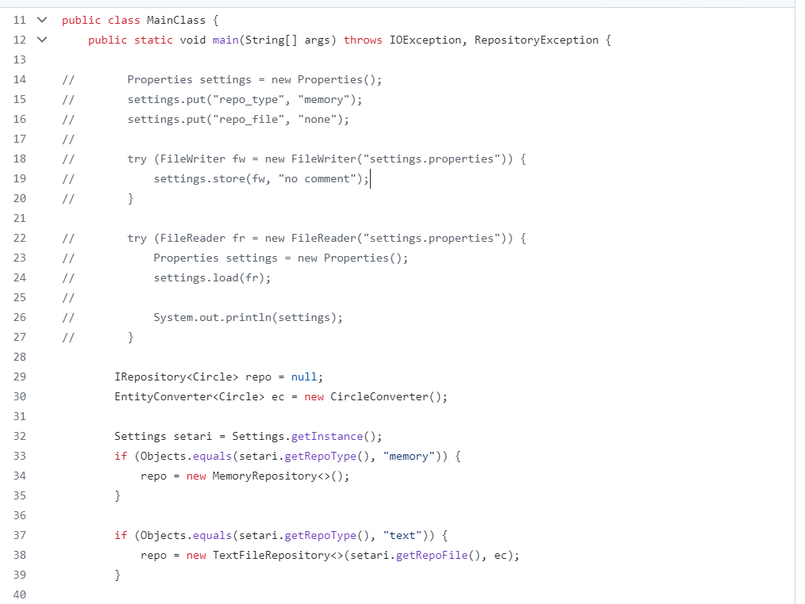

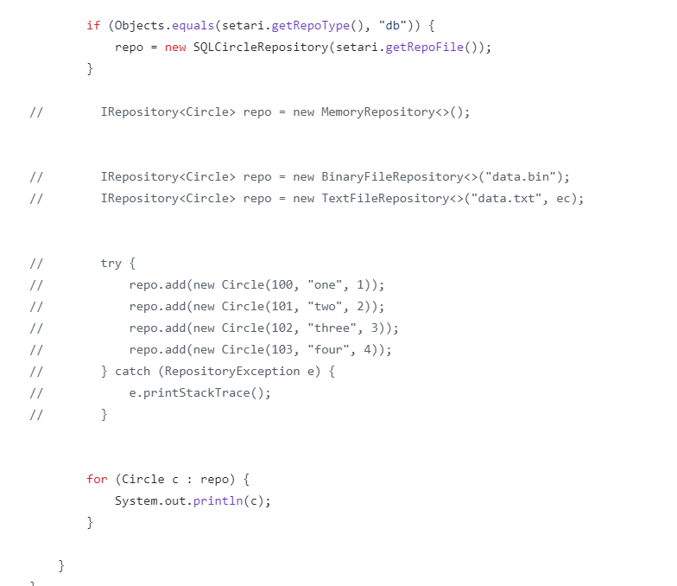

**Serializare**

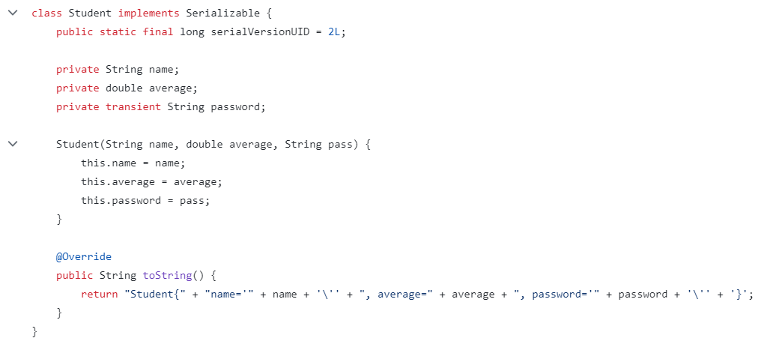

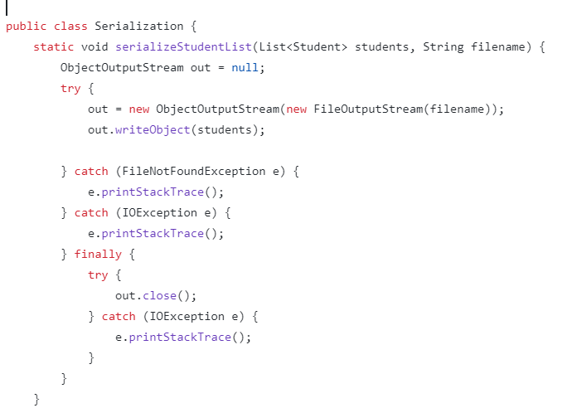

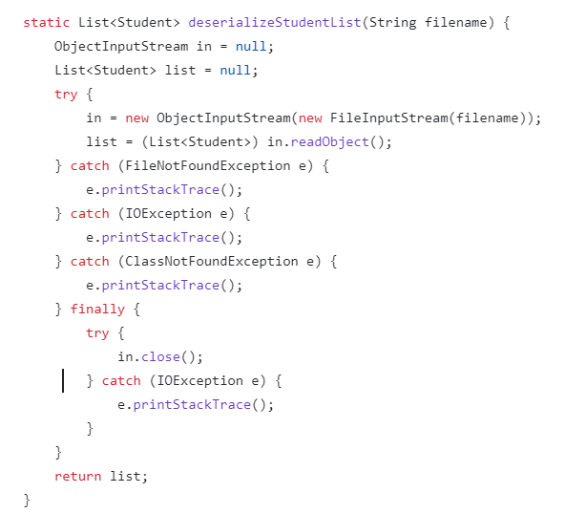



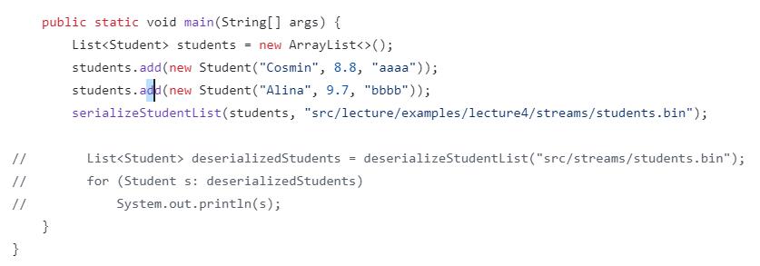

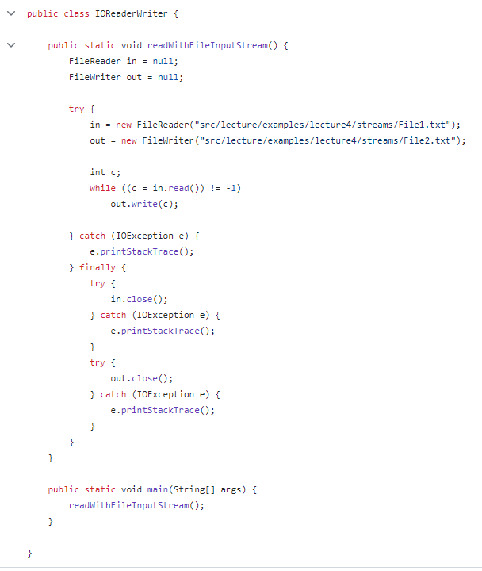



**EXERCITIU**



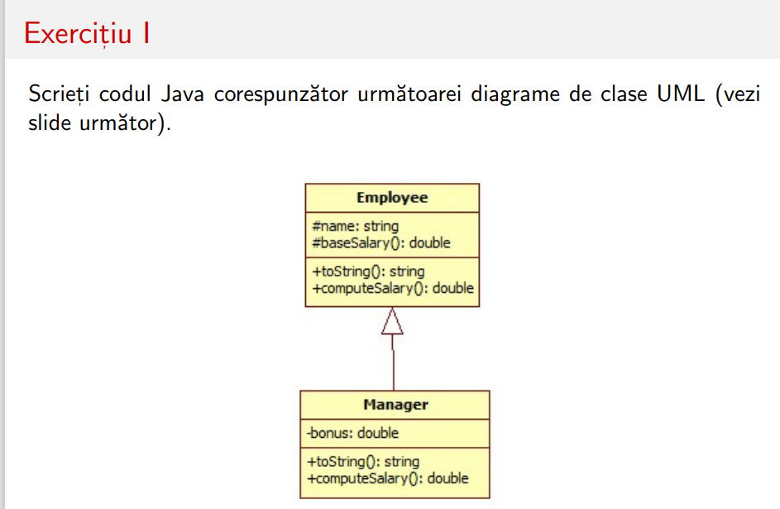



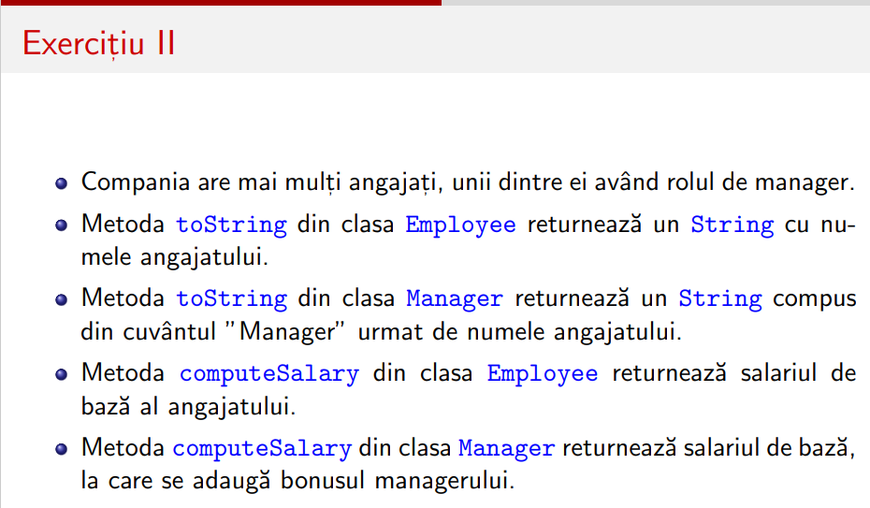 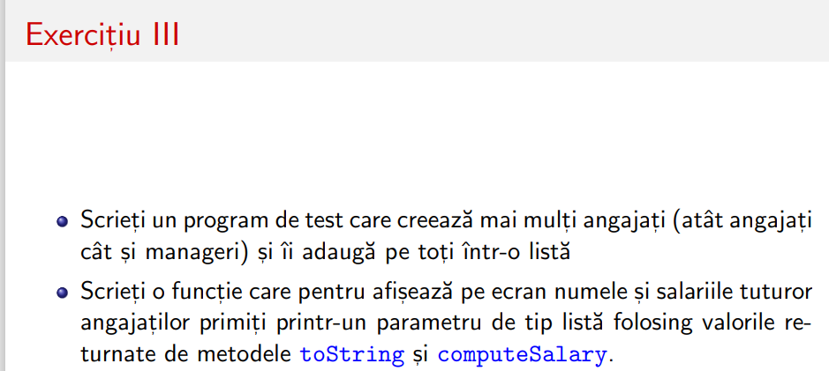



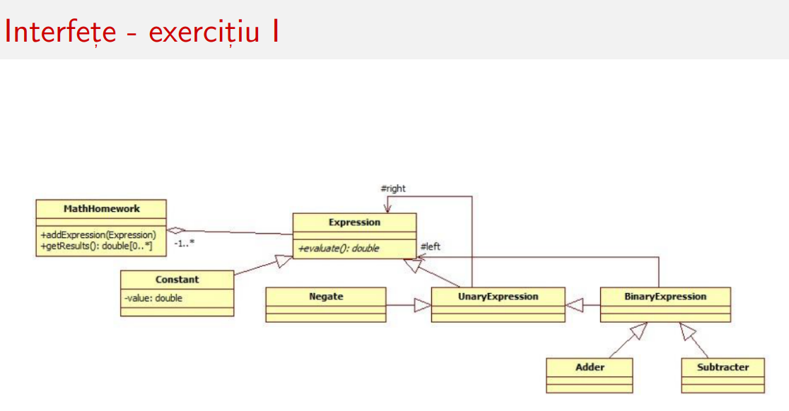



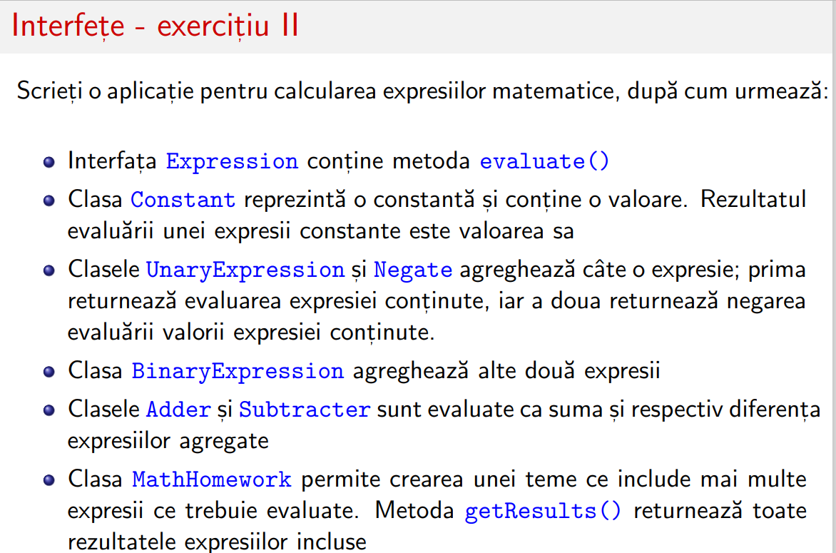



**Mostenire**

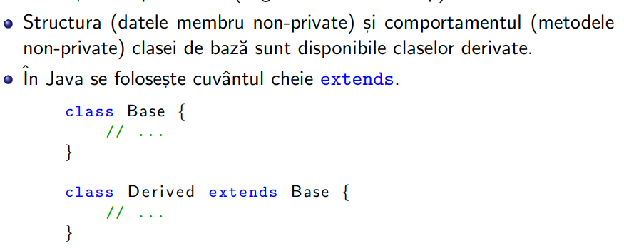



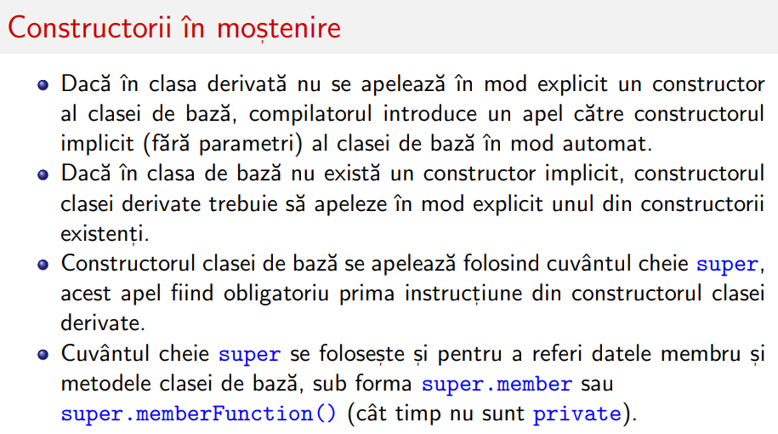



**Interfete**

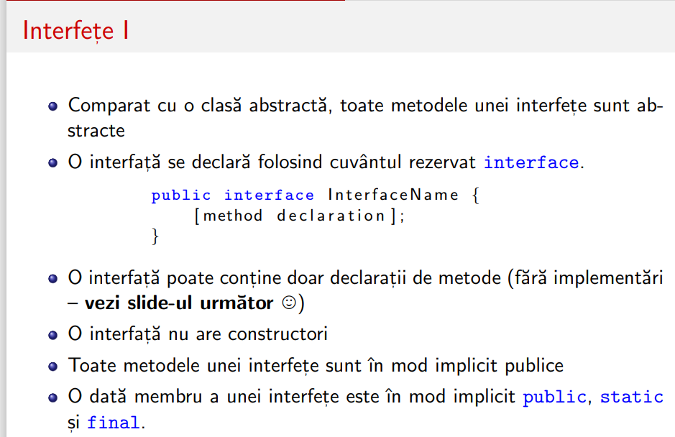 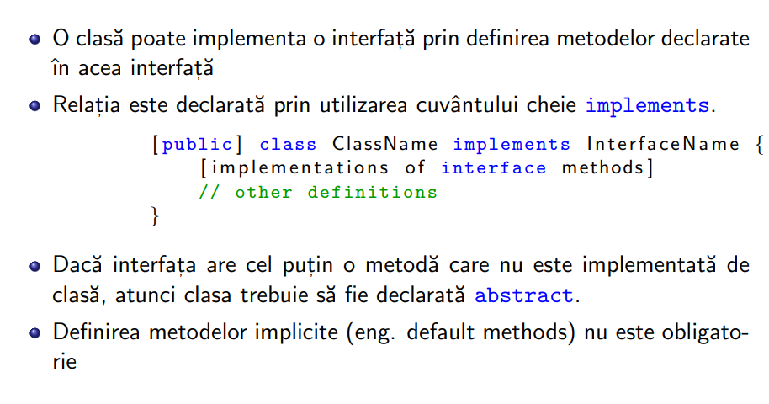

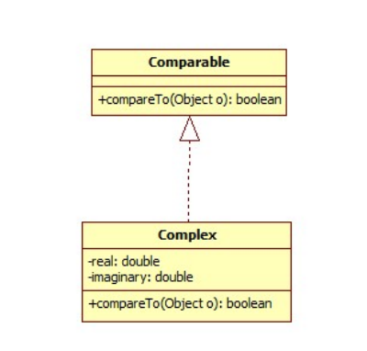 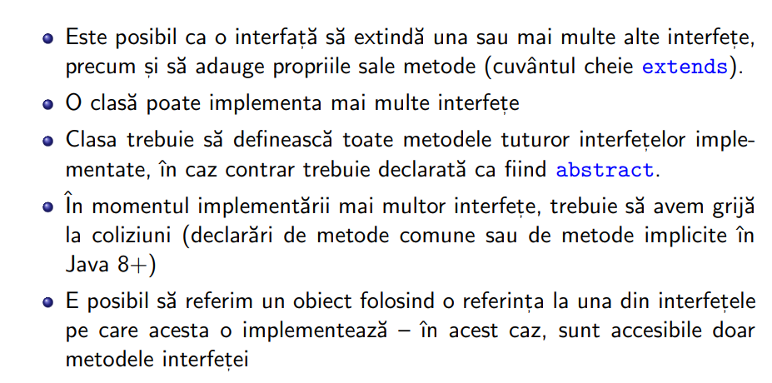

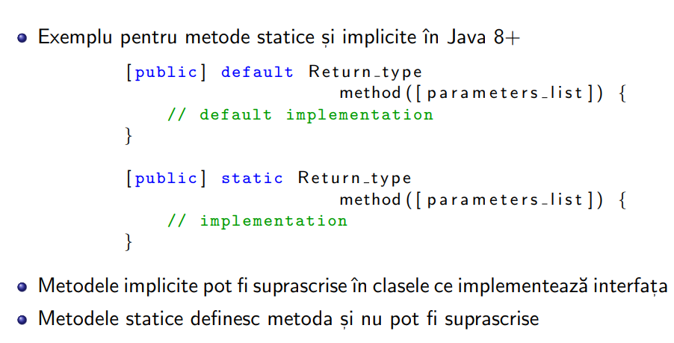 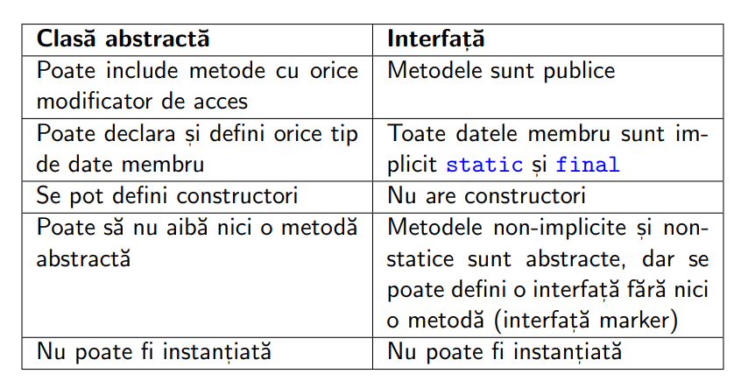

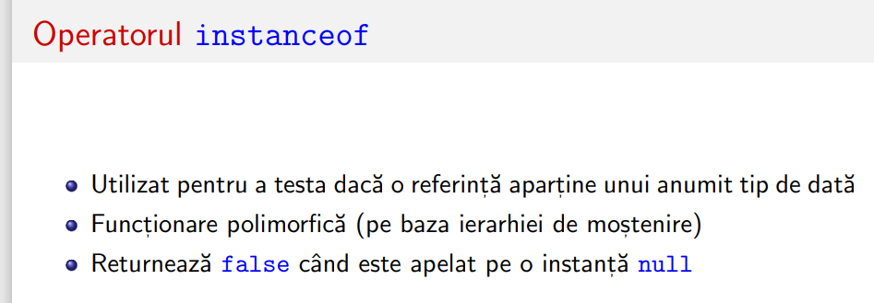



**1 (1p). Compare overriding vs. overloading in Java.**

* **Overriding:** Occurs when a subclass provides a specific implementation for a method that is already provided by its superclass. The method in the subclass has the same name, return type, and parameters as the one in the superclass.
* **Overloading:** Occurs when there are multiple methods in the same class with the same name but different parameters (either a different number of parameters or different types).

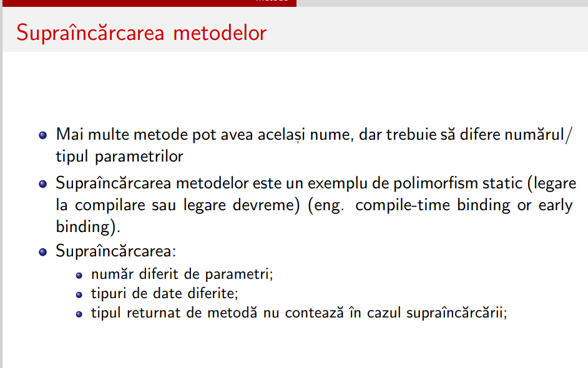 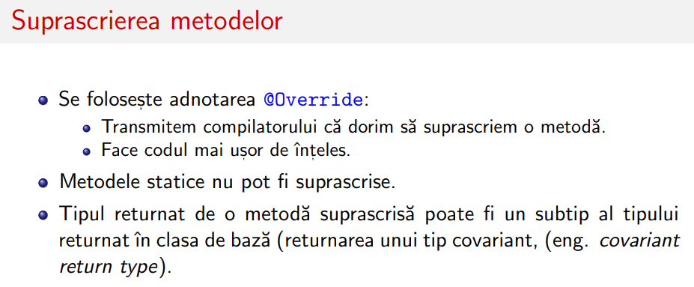



* **Overriding:** Used for achieving runtime polymorphism. It allows a subclass to provide a specific implementation for a method defined in its superclass.
* **Overloading:** Used for creating multiple methods with the same name within a class, but with different parameter lists. It enhances code readability and flexibility.
* **Inheritance:**
  + **Overriding:** Requires inheritance. The overridden method must be declared in a superclass, and the overriding method must be in a subclass.
  + **Overloading:** Does not require inheritance. Overloaded methods can be in the same class.
* **Method Signature:**
  + **Overriding:** The method signature (name, return type, and parameters) must be the same in both the superclass and subclass.
  + **Overloading:** The method signature must be different, either in terms of the number or types of parameters.
* **Execution:**
  + **Overriding:** The actual method that gets executed is determined at runtime based on the type of the object.
  + **Overloading:** The method to be executed is determined at compile-time based on the method signature.
* **Access Modifier:**
  + **Overriding:** The access modifier of the overriding method in the subclass must be the same or less restrictive than the overridden method in the superclass.
  + **Overloading:** There are no such restrictions related to access modifiers.

overriding is about providing a specific implementation for a method in a subclass, while overloading is about creating multiple methods with the same name in a class, each having a different signature. Both concepts contribute to the flexibility and extensibility of Java code.



FINAL

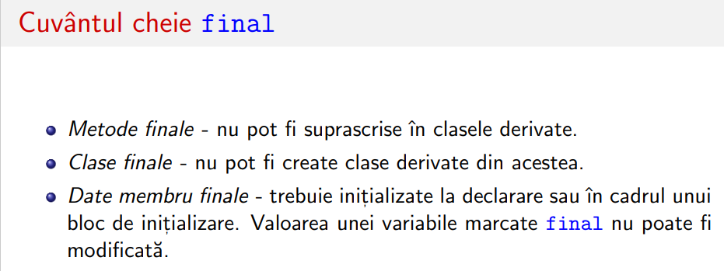

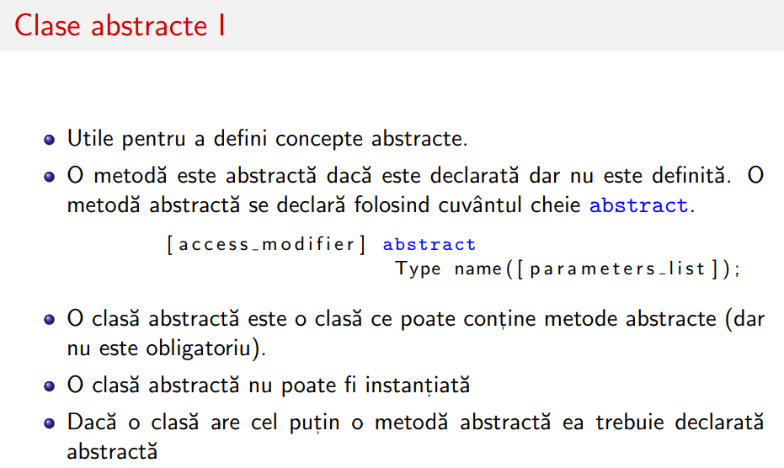 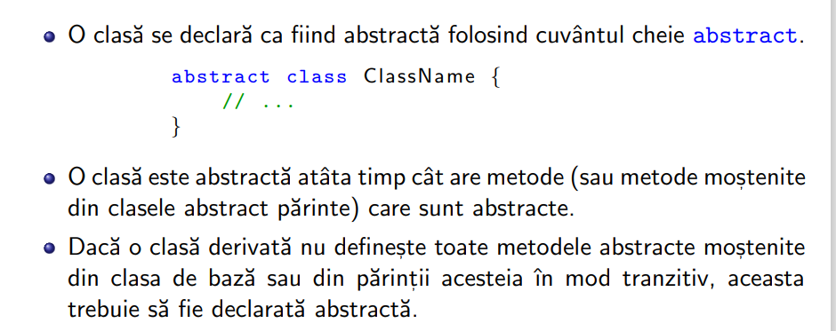



Pachete

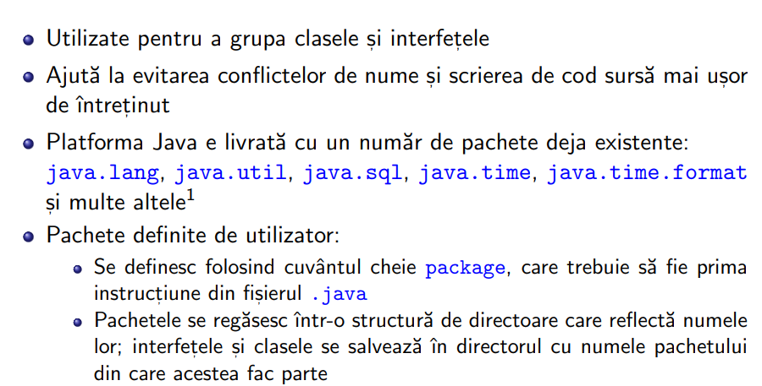 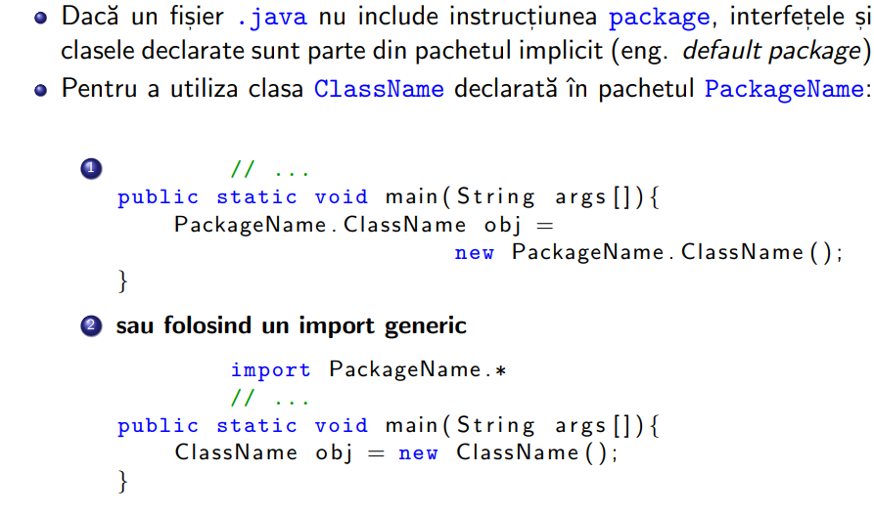



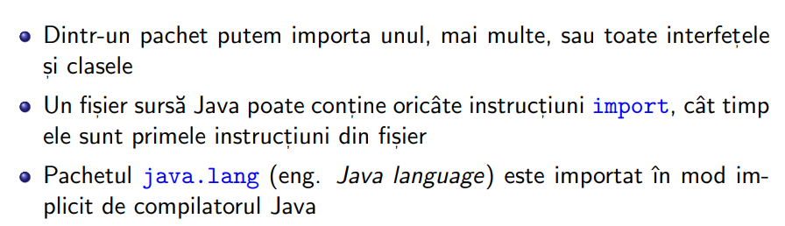 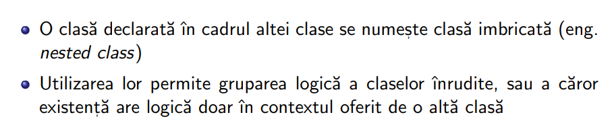

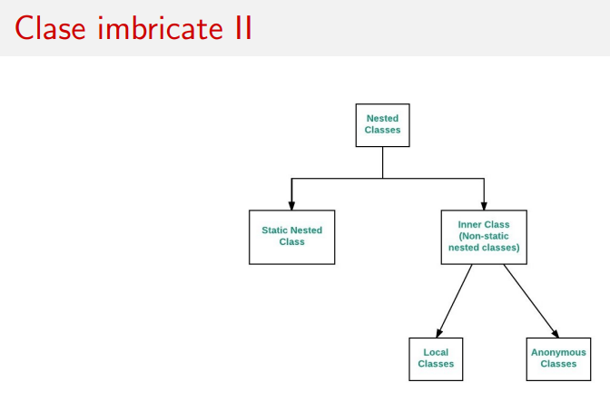 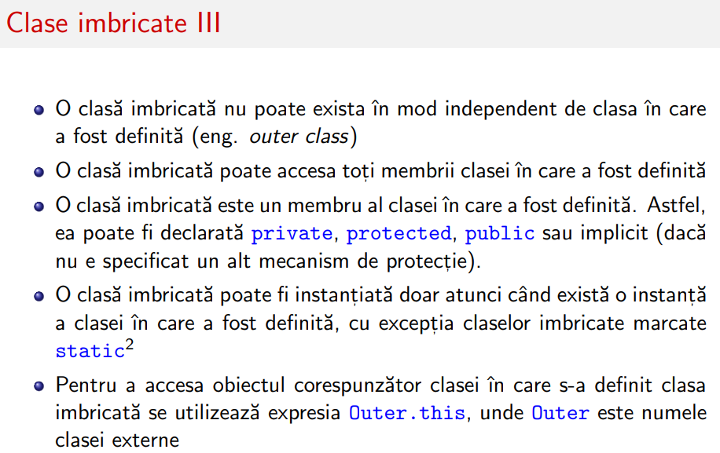

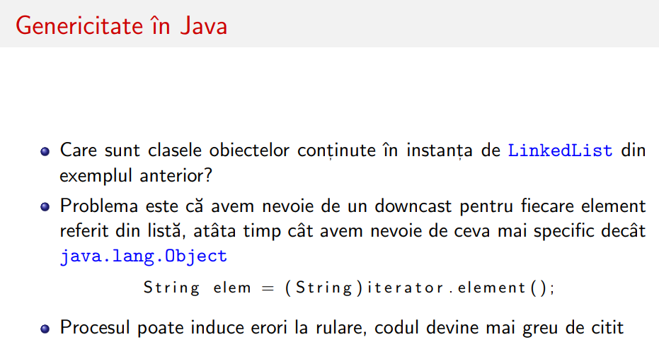 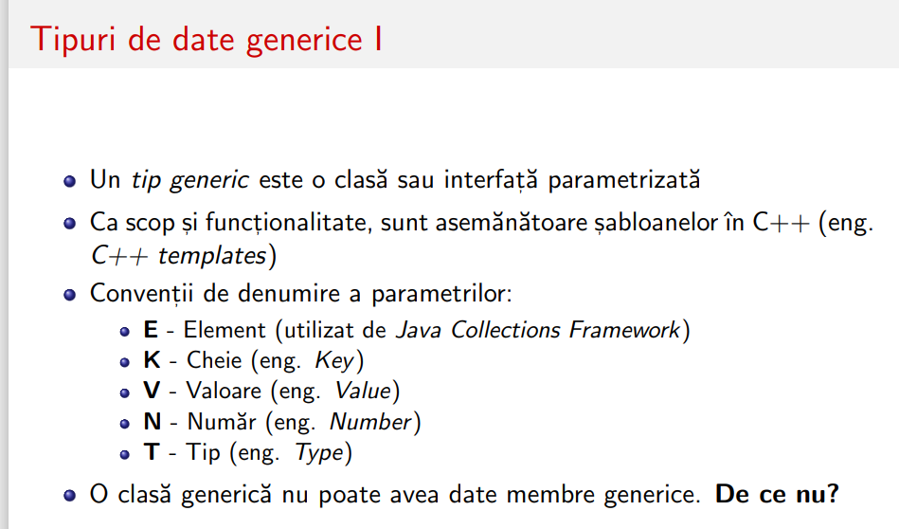



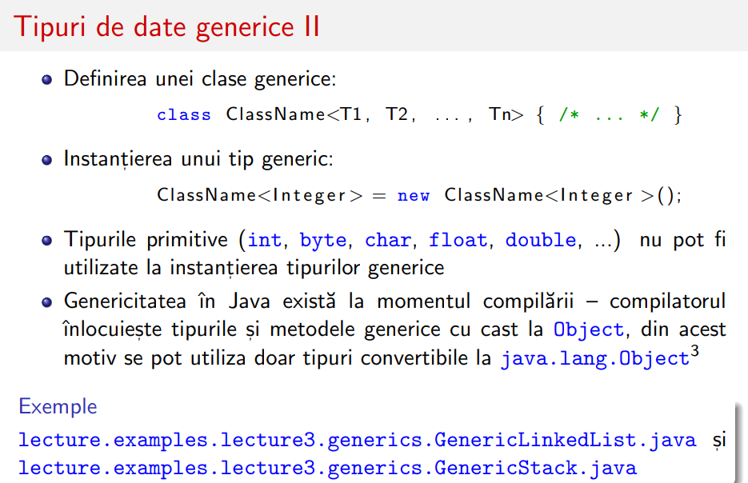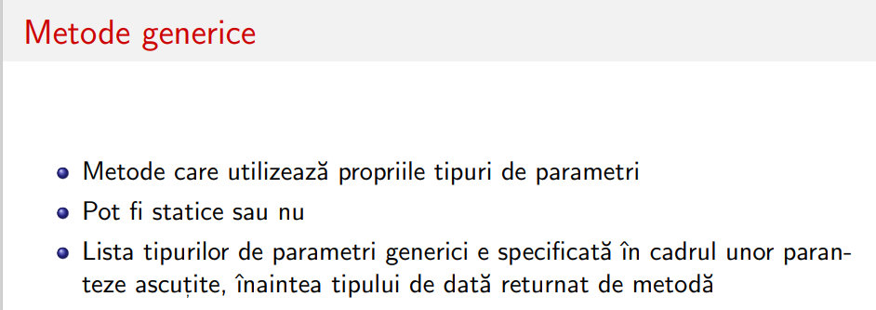



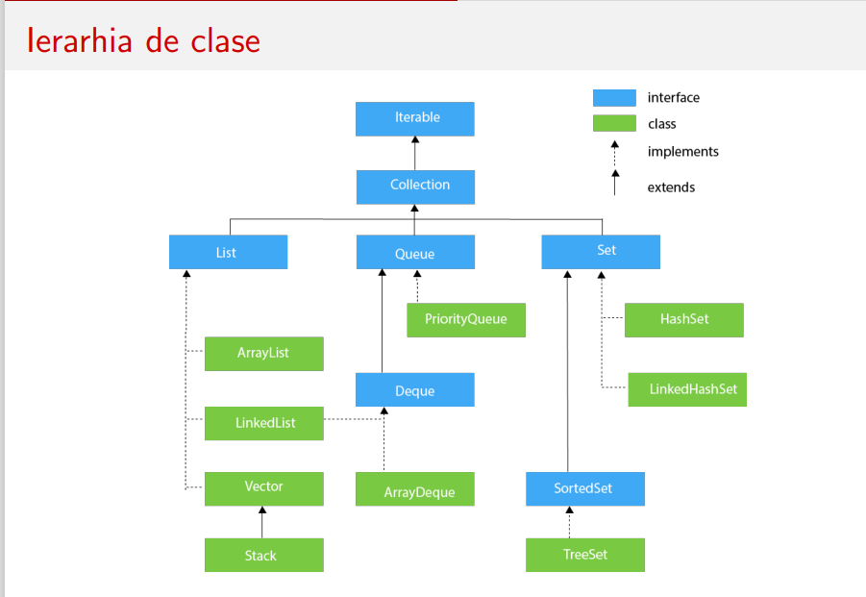

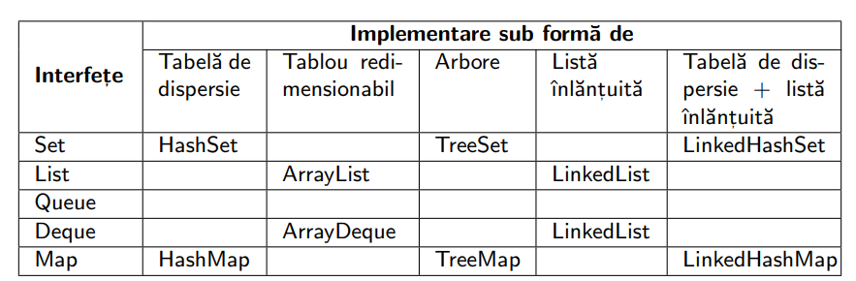

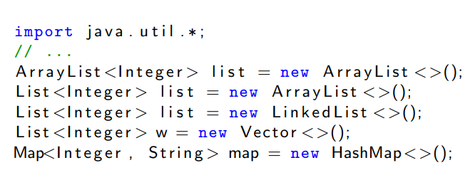

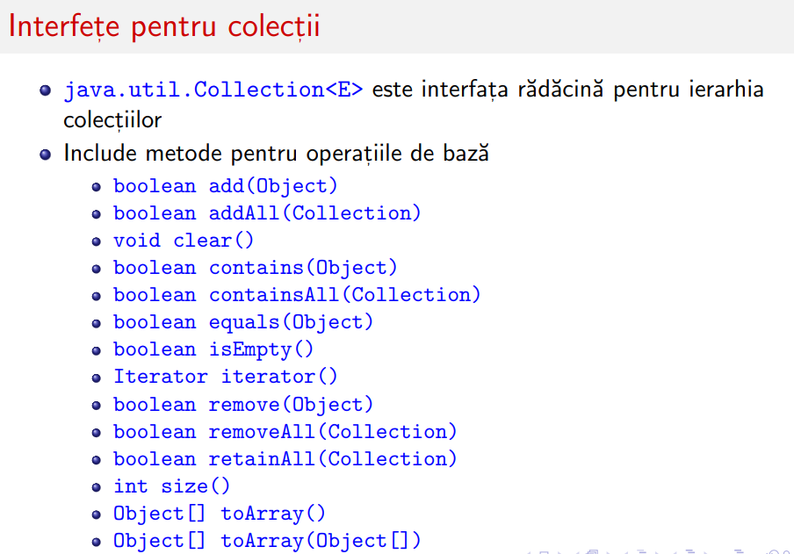 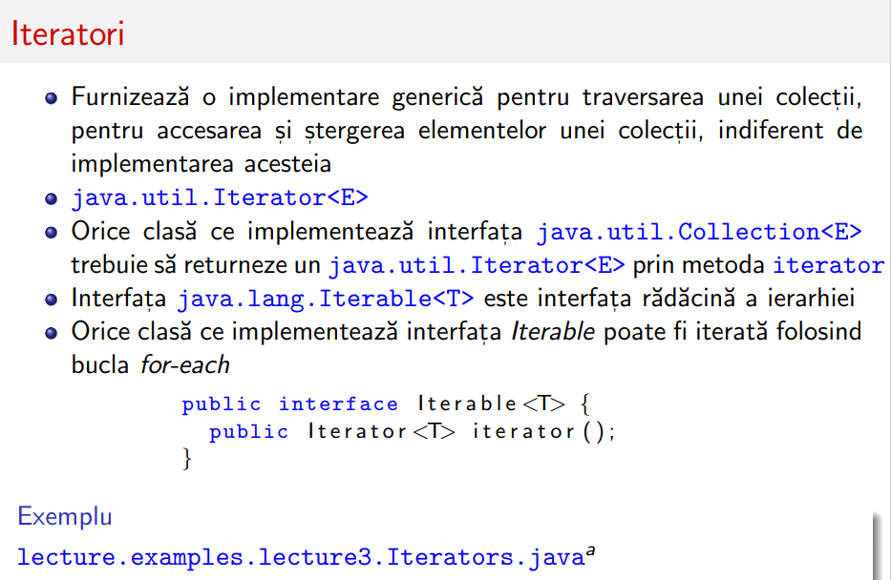



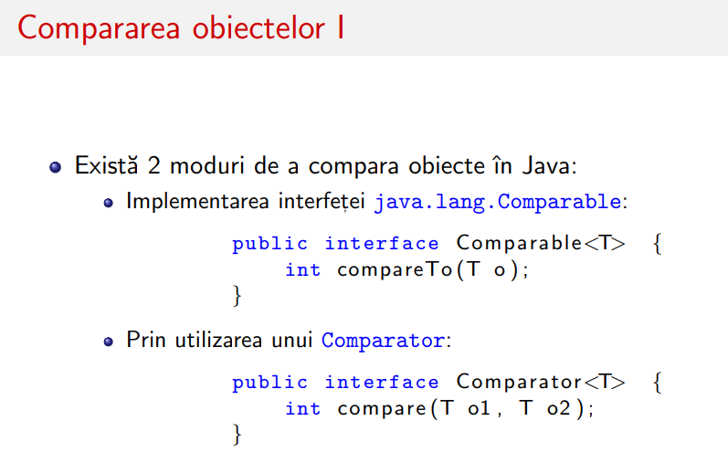 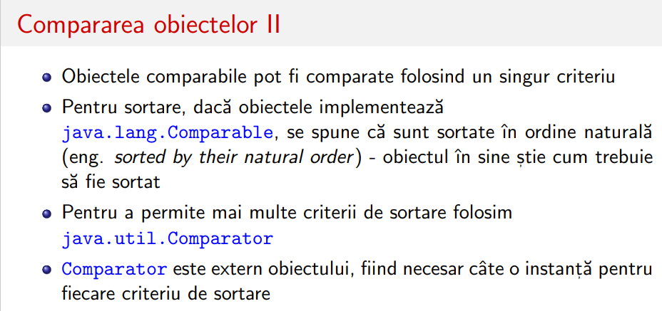

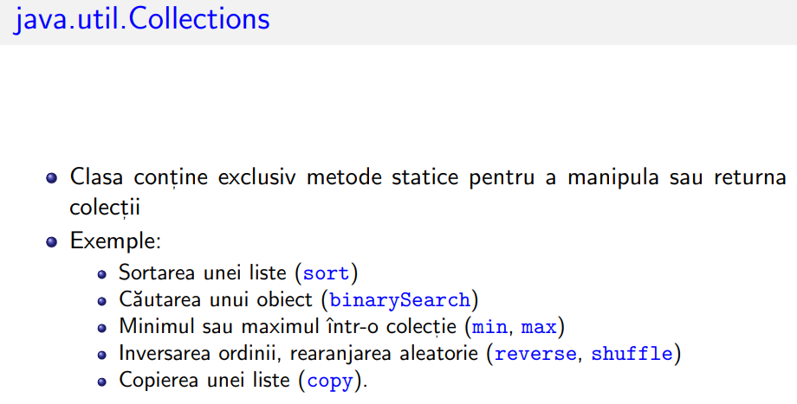 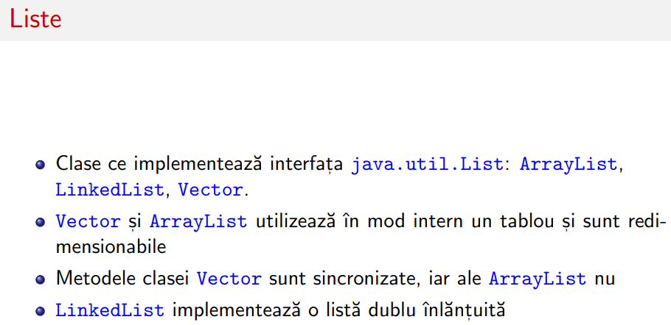

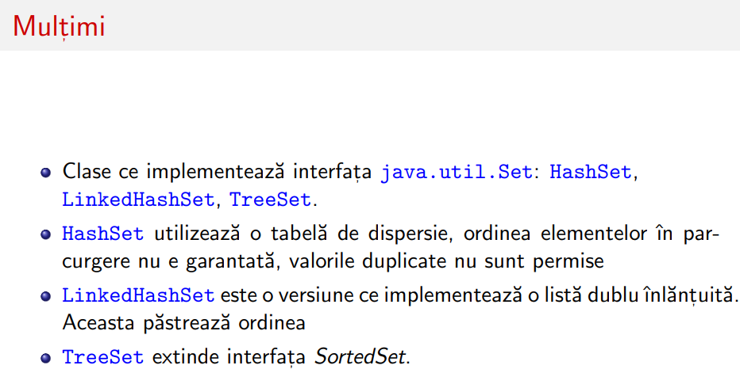



**2 (3p). Given the following collection**

List<Integer> numbers = Arrays.asList(1, 2, 3, 4, 5, 6, 7, 8,9,10,11,12,14,15);

Using Java functional style (Java streams),

please write a program that is doing the following operations in the following order:

1. –numarare numere pare

* List<Integer> **numbers** = Arrays.asList(1, 2, 3, 4, 5, 6, 7, 8, 9, 10, 11, 12, 14, 15);

List<Integer> unevenNumbers = **numbers**.stream()

.filter(number -> number % 2 != 0)

.collect(Collectors.toList());

System.out.println("Uneven Numbers: " + unevenNumbers);

a)keep only the numbers which are multiple of 5 or multiple of 2;

List<Integer> filteredNumbers = **numbers**.stream()

.filter(number -> number % 5 == 0 || number % 2 == 0)

.collect(Collectors.toList());



System.out.println("Numbers multiple of 5 or 2: " + filteredNumbers);

**a ‘’) Sort ascending / Sort descending**

List<Integer> numbers = Arrays.asList(1, 2, 3, 4, 5, 6, 7, 8, 9, 10, 11, 12, 14, 15);

List<Integer> sortedAscending = numbers.stream()

.sorted() sau .sorted((num1, num2) -> Integer.compare(num2, num1))

.collect(Collectors.toList());

System.out.println("Sorted Ascending: " + sortedAscending);

1. transform each remaining number into a string, that consists of a prefix "N", the number and the suffix "R"

(eg. 5 is transformed into "N5R")

c)concatenate all the strings

List<Integer> numbers = Arrays.asList(1, 2, 3, 4, 5, 6, 7, 8, 9, 10, 11, 12, 14, 15);

// a) Keep only the numbers which are multiple of 5 or multiple of 2

List<Integer> filteredNumbers = numbers.stream()



.filter(number -> number % 5 == 0 || number % 2 == 0)

.collect(Collectors.toList());

// b) Transform each remaining number into a string with prefix "N" and suffix "R"

List<String> transformedStrings = filteredNumbers.stream()

.map(number -> "N" + number + "R")

.collect(Collectors.toList());

// c) Concatenate all the strings

String concatenatedString = transformedStrings.stream()

.collect(Collectors.joining());

// Print the results

System.out.println("a) Filtered Numbers: " + filteredNumbers);

System.out.println("b) Transformed Strings: " + transformedStrings);

System.out.println("c) Concatenated String: " + concatenatedString);

}

--------------------

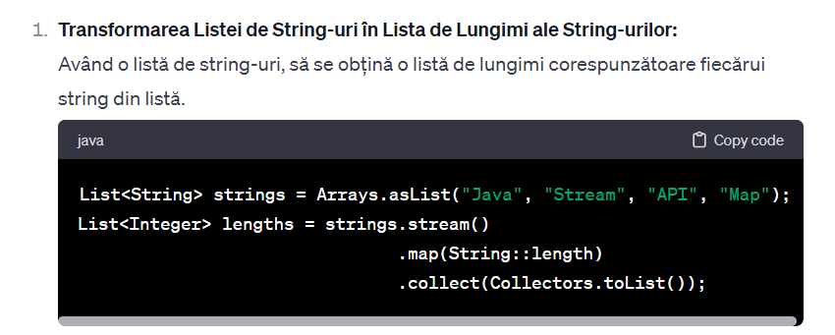



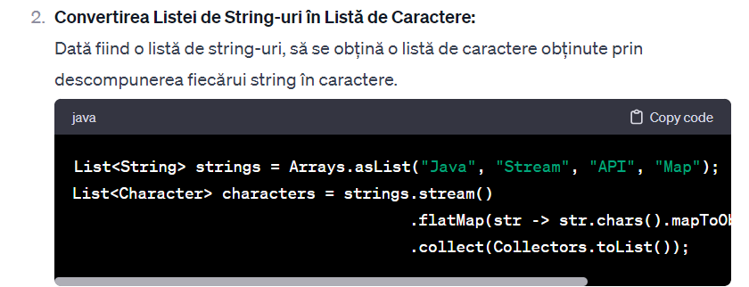 List<String> strings = Arrays.asList("Java", "Stream", "API", "Map");

List<Character> characters = strings.stream()

.flatMap(str -> str.chars().mapToObj(c -> (char) c))

.collect(Collectors.toList());

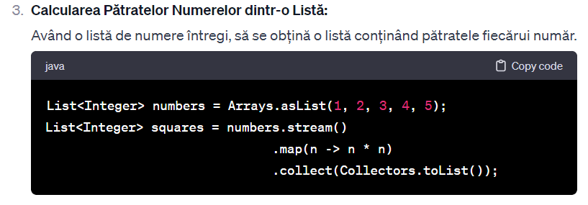

1. presusupunem ca avem Lista de stringuri de la inceput

* sortam stringurile alphabetic crescator/descrecator



1. presusupunem ca avem Lista de persoane de la inceput List<Persoana> persoane

class Persoana {

private int age;

private String nume;

private String prenume;

private double inaltime;

private List<String> culoriPreferate;

public Persoana(int age, String nume, String prenume, double inaltime, List<String> culoriPreferate) {

this.age = age;

this.nume = nume;

this.prenume = prenume;

this.inaltime = inaltime;

this.culoriPreferate = culoriPreferate;



}

- sortam persoanele dupa varsta .getAge()

List<Persoana> persoane = Arrays.asList(

new Persoana(25, "Popescu", "Ion", 1.75, Arrays.asList("albastru", "verde")),

new Persoana(30, "Ionescu", "Maria", 1.60, Arrays.asList("rosu", "galben")),

new Persoana(22, "Georgescu", "Andrei", 1.80, Arrays.asList("negru", "alb"))

);

// Sortare persoane după varstă

List<Persoana> persoaneSortateDupaVarsta = persoane.stream()

.sorted((p1, p2) -> Integer.compare(p1.getAge(), p2.getAge()))

.collect(Collectors.toList());

System.out.println("Persoane sortate după varstă:");

persoaneSortateDupaVarsta.forEach(System.out::println);

SAU ASA

List<Persoana> persoaneSortateDupaVarsta = persoane.stream()

.sorted(Comparator.comparing(**Persoana::getAge**))

.collect(Collectors.toList());

* filtram sa ramana doar persoanele care au inaltimea mai mare de 1.50 metri

List<String> persoaneCuInaltimeMaiMare = persoane.stream()

.filter(p -> p.getInaltime() > 1.50)

.map(p -> p.getNume() + " " + p.getPrenume())

.collect(Collectors.toList());

System.out.println("\nPersoane cu înălțime mai mare de 1.50 metri:");

persoaneCuInaltimeMaiMare.forEach(System.out::println);

SAU ASA

List<Persoana> persoaneSortateDupaNume = persoane.stream()

.sorted(Comparator.comparing(Persoana::getNume))

.collect(Collectors.toList());

* **2 cerinte la care ne trebuie .map**  
  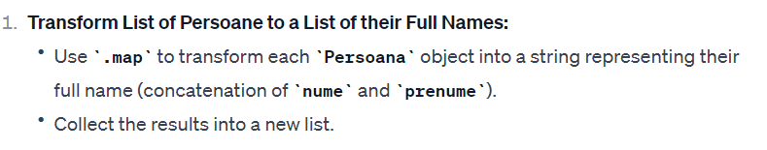



List<String> fullNames = persoane.stream()

.map(persoana -> persoana.getNume() + " " + persoana.getPrenume())

.collect(Collectors.toList());

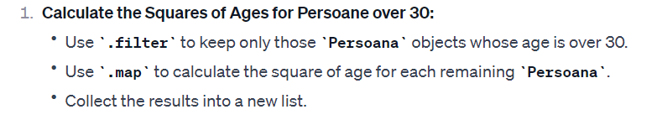

List<Integer> squaresOfAges = persoane.stream()

.filter(persoana -> persoana.getAge() > 30)

.map(persoana -> persoana.getAge() * persoana.getAge())

.collect(Collectors.toList());

**3 (3p). Given the following four classes in Java:**

class A {...}

class B extends A {...}

class C extends B {...}

class Amain {

A method1(ArrayList<...> list) {

if (list.isEmpty()) return null;

else return list.get(1);

}

void method2(ArrayList<...> list, C elem) {

list.add(elem);

}

void method3(C elem) {

ArrayList<A> listA = new ArrayList<A>(); listA.add(new A());

ArrayList<B> listB = new ArrayList<B>(); listB.add(new B());

ArrayList<C> listC = new ArrayList<C>(); listC.add(new C());

this.method1(listA);

this.method1(listB);

this.method1(listC);

this.method2(listA, elem);

this.method2(listB, elem);

this.method2(listC, elem);

}

}

Compute the most specific signatures for the class Amain methods (method1 and method2) such that the entire program is correct.



If it is not possible to find the types justify your answer.

Discuss line by line the correctness of the above program.

**4 (2p). What is a CountDownLatch in Java.**

The main idea is that a CountDownLatch is initialized with a count, and as threads complete their tasks, the count is decremented. Threads that need to wait for the completion of these tasks can call the await() method, which will block until the count reaches zero.

Suppose you have a task that involves multiple threads, and you want to coordinate their execution. You can use **CountDownLatch** to make sure a particular task is not started until all the prerequisite tasks are completed

**1 (1p). Compare interfaces vs. abstract classes in Java.**

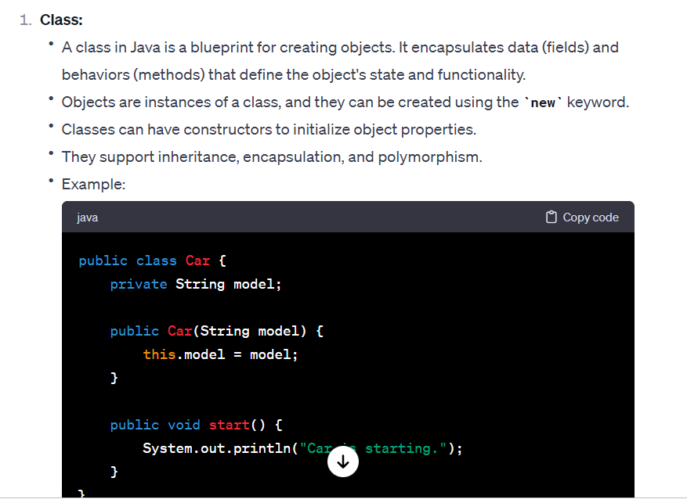

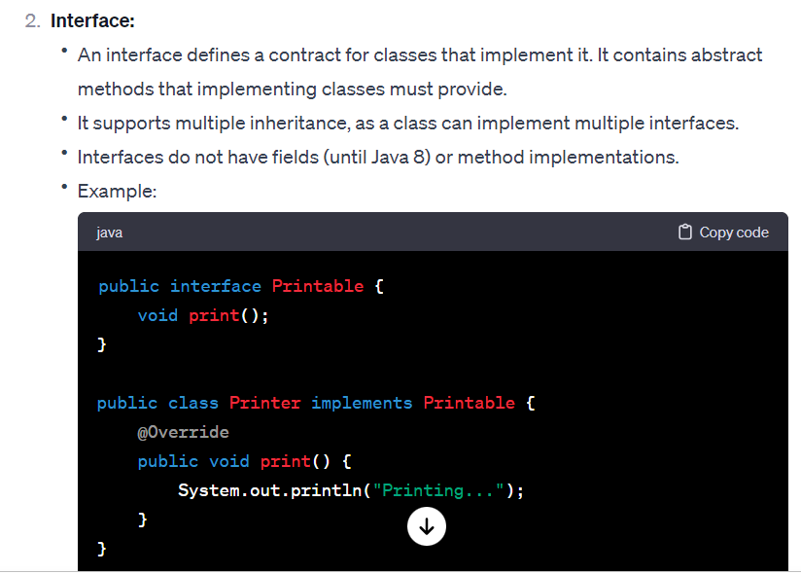



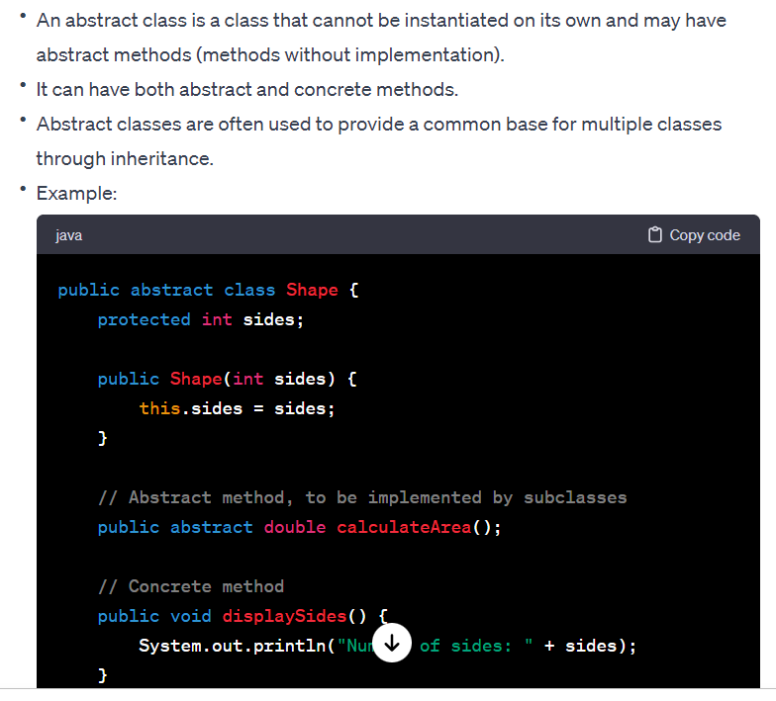

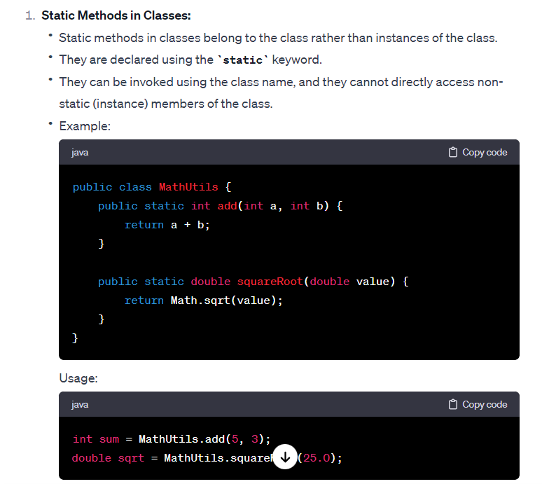



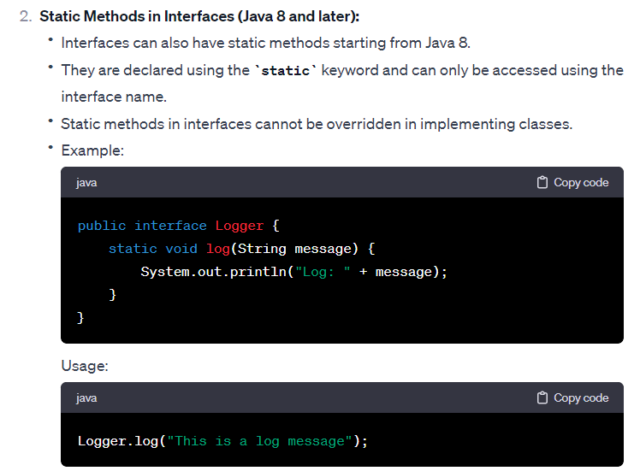

**Interface vs functional interface**

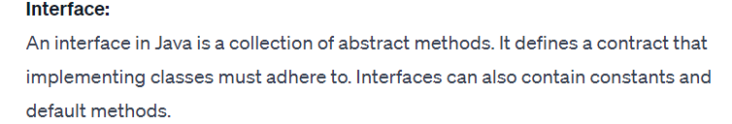



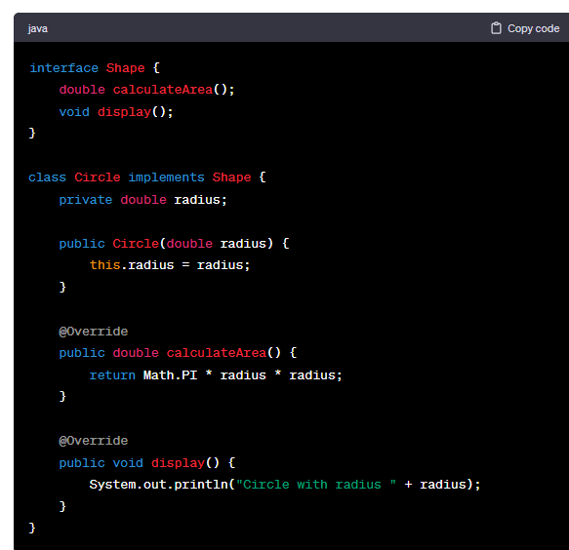

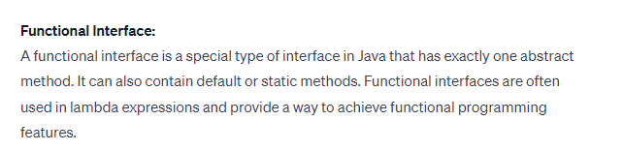



@FunctionalInterface



interface StringProcessor {

String process(String s);

}

public class Main {

public static void main(String[] args) {

StringProcessor toUpperCase = s -> s.toUpperCase();

StringProcessor firstLetterToUpper = s -> s.substring(0, 1).toUpperCase() + s.substring(1);

System.out.println(toUpperCase.process("hello")); // Output: HELLO

System.out.println(firstLetterToUpper.process("world")); // Output: World

}

}

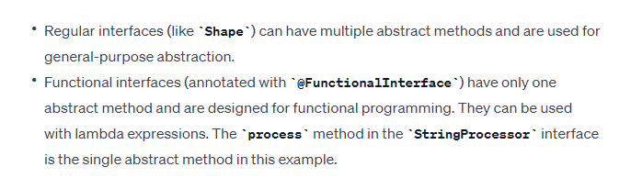

2 (3p). Given the following collection

List<Integer> numbers = Arrays.asList(1, 2, 3, 4, 5, 6, 7, 8,9,10,11,12,14,15);

Using Java functional style (Java streams),

please write a program that is doing the following operations in the following order:

a)eliminates all the numbers which are not multiple of 3 or multiple of 7;

b)transform each remaining number into its predecessor (eg. 3 is transformed into 2);

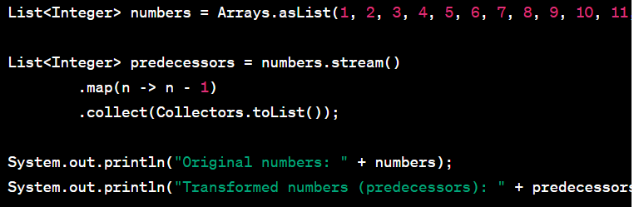



c)compute the sum modulo 5 of the remaining numbers (eg. (2 +4) mod 5=1)

3 (3p). Given the following four classes in Java:

interface D {

}

class A implements D {

// Implementation for class A

}

class B extends A implements D {

// Implementation for class B

}

class C extends A implements D {

// Implementation for class C

}

class Amain {

D method1(ArrayList<...> list) {

if (list.isEmpty()) return null;

else return list.get(1);

}

void method2(ArrayList<...> list, C elem) {

list.add(elem);

}

void method3(C elem) {

ArrayList<A> listA = new ArrayList<A>();

listA.add(new A());

listA.add(new A());

ArrayList<B> listB = new ArrayList<B>();

listB.add(new B());

listB.add(new B());

ArrayList<C> listC = new ArrayList<C>();

listC.add(new C());

listC.add(new C());

this.method1(listA);

this.method1(listB);

this.method1(listC);



this.method2(listA, elem);

this.method2(listB, elem);

this.method2(listC, elem);

}

}

Compute the most specific signatures for the class Amain methods (method1 and method2)

such that the entire program is correct.

If it is not possible to find the types justify your answer.

Discuss line by line the correctness of the above program.

4 (2p). What is an Atomic Variable in Java.

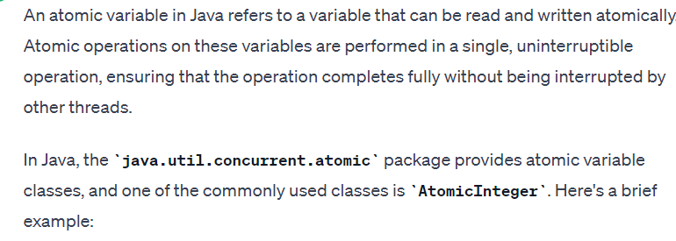

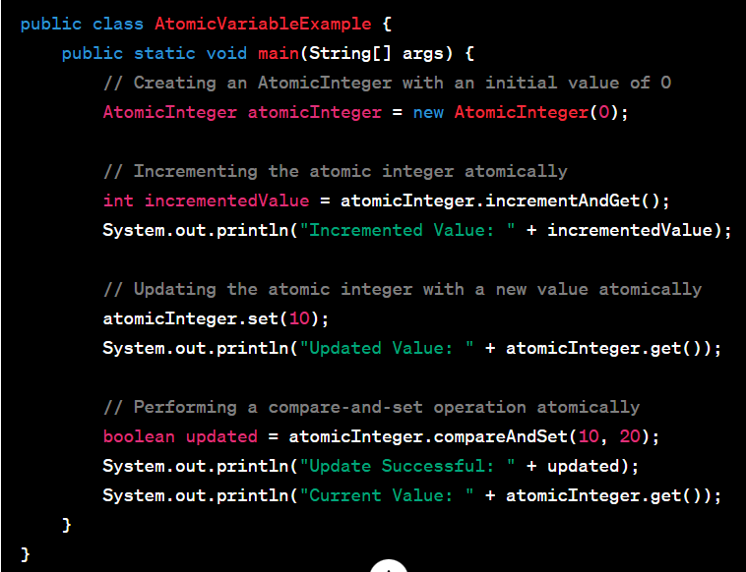



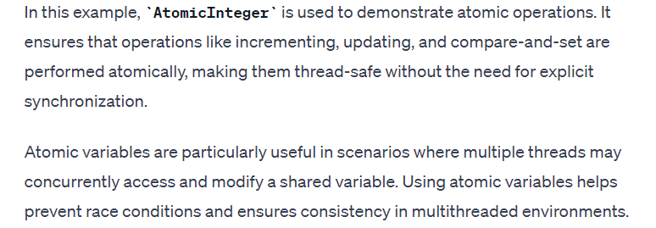

1.(3p). Compare static vs non-static methods in Java.

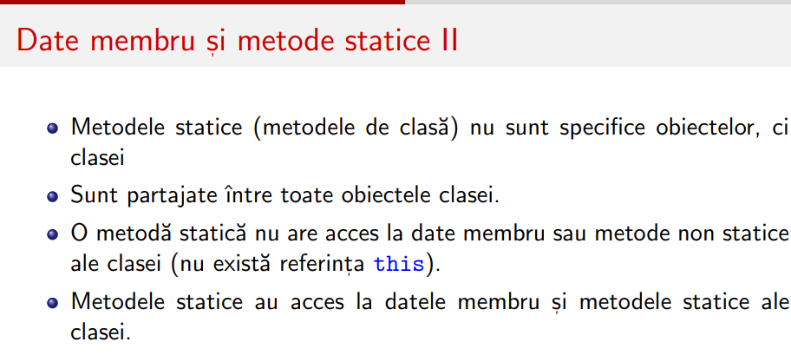

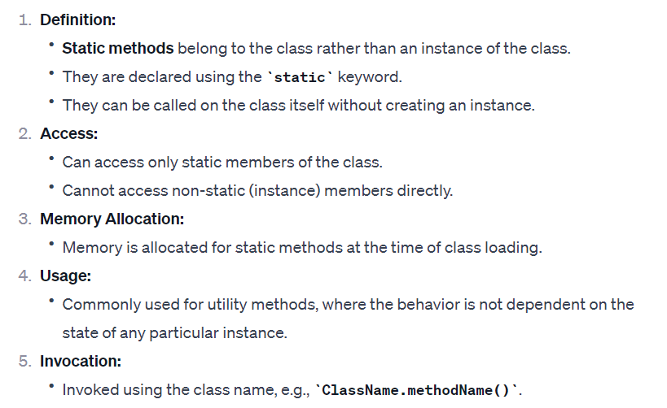

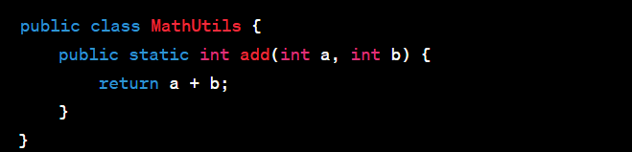



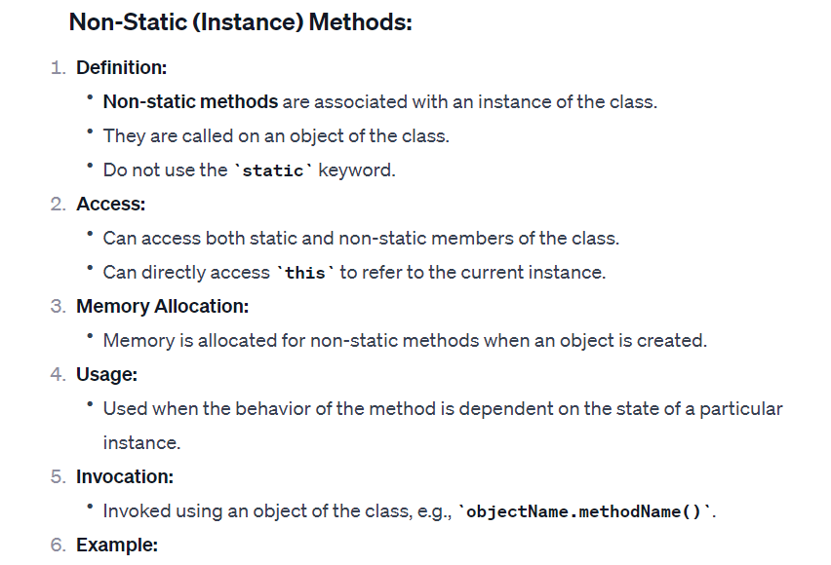

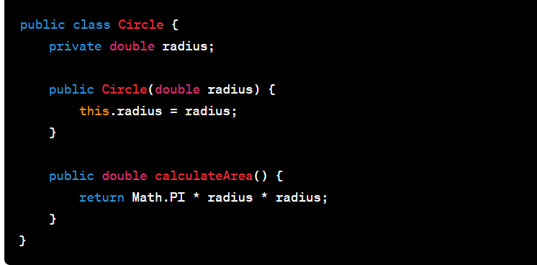

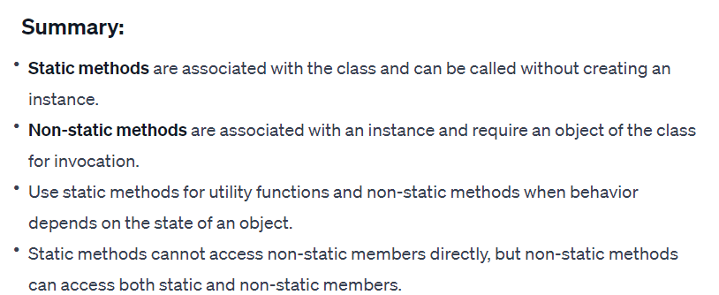



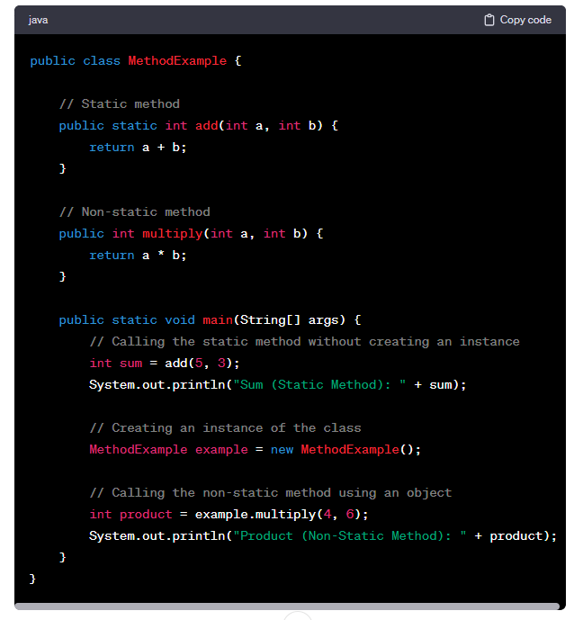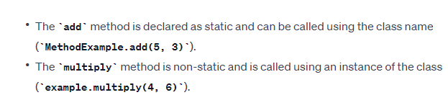



2.(3p). Given the following collection

List<Integer> numbers = Arrays.asList(1, 2, 3, 4, 5, 6, 7, 8,9,10,11,12,14,15,16);



Using Java functional style (Java streams),

please write a program that is doing the following operations in the following order:

a)eliminates all the numbers which are not multiple of 4;

b)transform each remaining number into its succesor (eg. 4 is transformed into 5);

c)compute the sum modulo 2 of the remaining numbers (eg. (9 +5) mod 2=0)

d)transform the result into a list

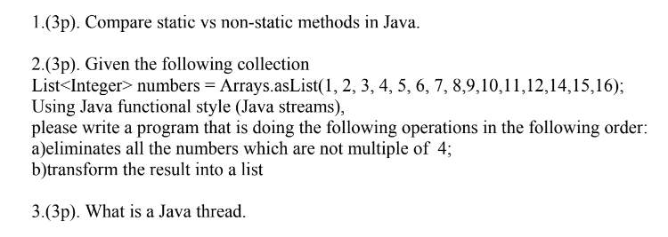



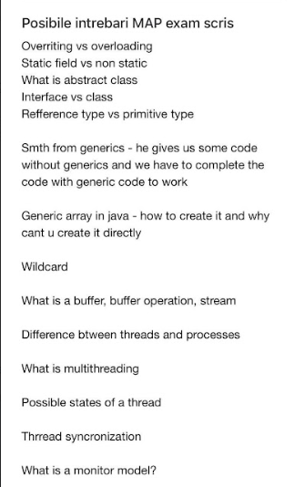



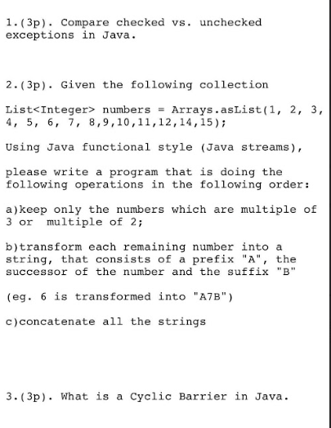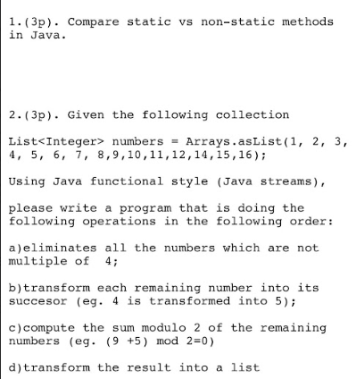



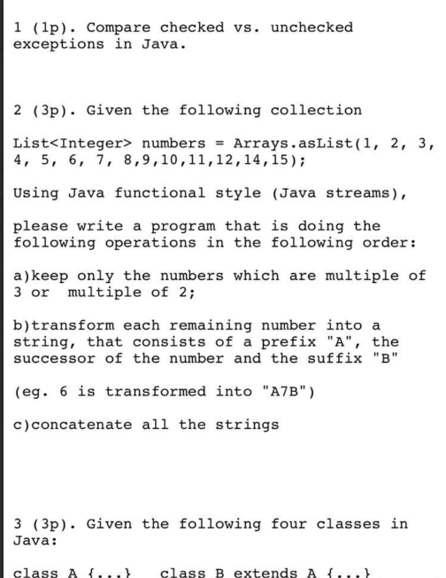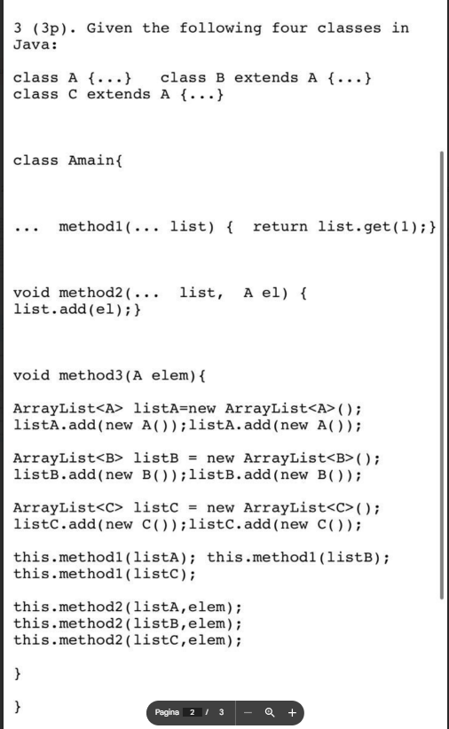



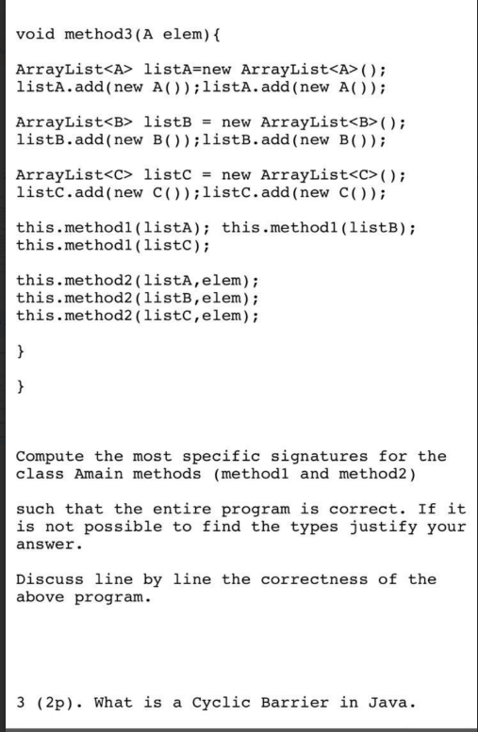

2 (3p). Given the following collection

List<Integer> numbers = Arrays.asList(1, 2, 3, 4, 5, 6, 7, 8,9,10,11,12,14,15,16);



Using Java functional style (Java streams),

please write a program that is doing the following operations in the following order:

a)eliminates all the numbers which are not multiple of 4;

b)transform each remaining number into its succesor (eg. 4 is transformed into 5);

c)compute the sum modulo 2 of the remaining numbers (eg. (9 +5) mod 2=0)

3 (3p). Given the following four classes in Java:

class A {...} class B extends A {...} class C extends A {...}

class Amain{

A method1(ArrayList<...> list) { if list.isEmpty() return null;

else return list.get(1);}

void method2(ArrayList<...> list) { list.add(null);}

void method3(){

ArrayList<A> listA=new ArrayList<A>(); listA.add(new A());

ArrayList<B> listB = new ArrayList<B>(); listB.add(new B());

ArrayList<C> listC = new ArrayList<C>(); listC.add(new C());

this.method1(listA); this.method1(listB); this.method1(listC);

this.method2(listA); this.method2(listB); this.method2(listC);

}

}

Compute the most specific signatures for the class Amain methods (method1 and method2)



such that the entire program is correct.

If it is not possible to find the types justify your answer.

Discuss line by line the correctness of the above program.

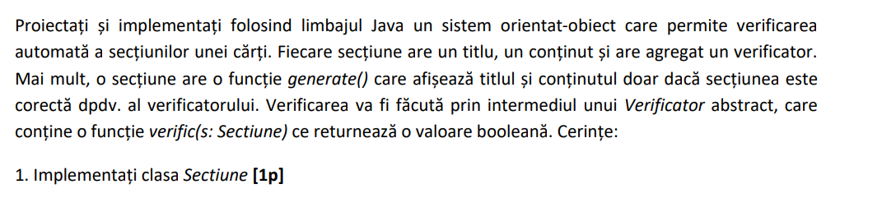



public class Sectiune {

private String titlu;

private String continut;

private Validator validator;

public Sectiune(String titlu, String continut, Validator validator) {

this.titlu = titlu;

this.continut = continut;

this.validator = validator;



}

public void generate() {

if (validator.verific(this)) {

System.out.println("Titlu: " + titlu);

System.out.println("Continut: " + continut);

} else {

System.out.println("Secțiunea nu este validă.");

}

}

// Getters and setters (not shown for brevity)

}

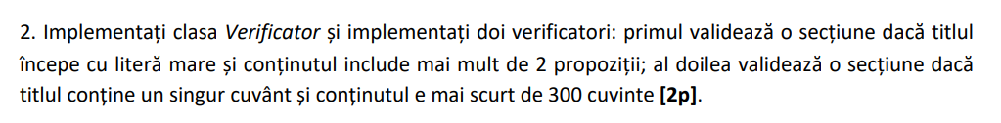

public abstract class Validator {

public abstract boolean verific(Sectiune sectiune);

}

public class PrimulValidator extends Validator {

@Override

public boolean verific(Sectiune sectiune) {

// Validează dacă titlul începe cu literă mare și conținutul are mai mult de 2 propoziții

return sectiune.getTitlu().matches("[A-Z].*") && countPropozitii(sectiune.getContinut()) > 2;

}



private int countPropozitii(String continut) {

// Implementați logica de numărare a propozițiilor

// Puteți adapta această logică în funcție de structura textului

// Aici am implementat o versiune simplificată

String[] propozitii = continut.split("[.!?]");

return propozitii.length;

}

}

public class AlDoileaValidator extends Validator {

@Override

public boolean verific(Sectiune sectiune) {

// Validează dacă titlul conține un singur cuvânt și conținutul are mai puțin de 300 de cuvinte

return sectiune.getTitlu().matches("\\w+") && countCuvinte(sectiune.getContinut()) < 300;

}

private int countCuvinte(String continut) {

// Implementați logica de numărare a cuvintelor

// Puteți adapta această logică în funcție de structura textului

// Aici am implementat o versiune simplificată

String[] cuvinte = continut.split("\\s+");

return cuvinte.length;

}

}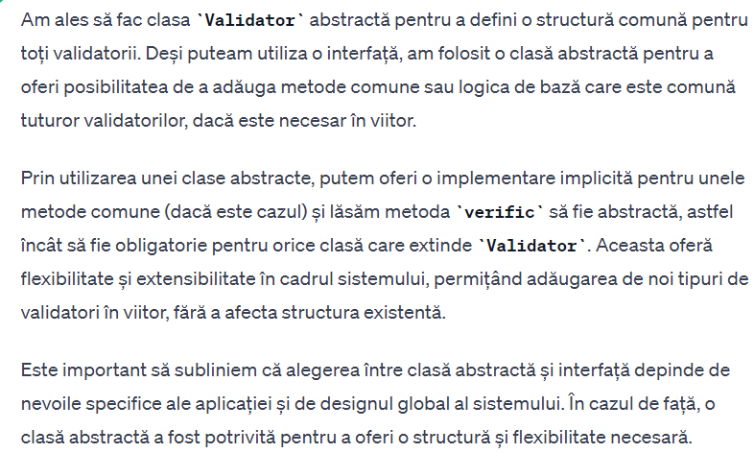

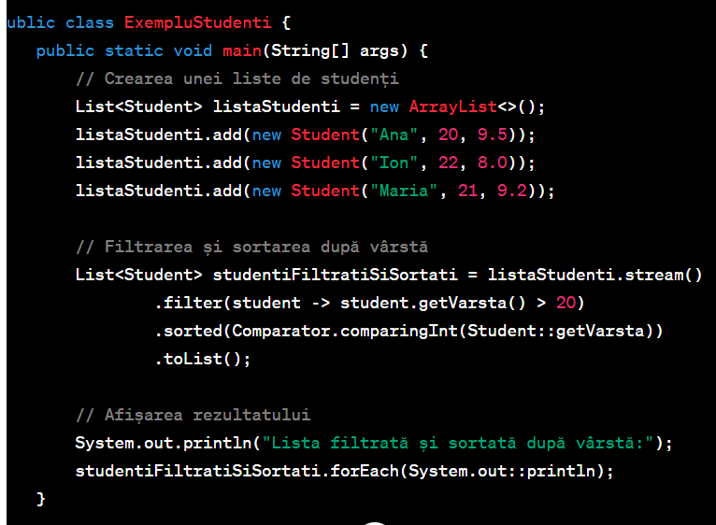



**Cursuri PROF 2023**

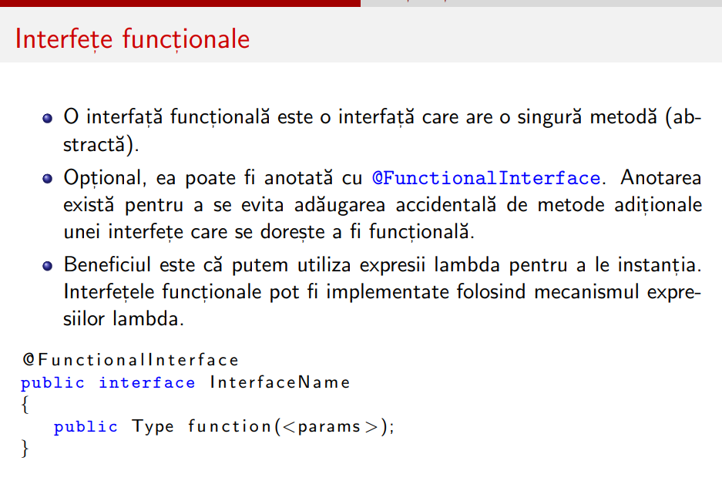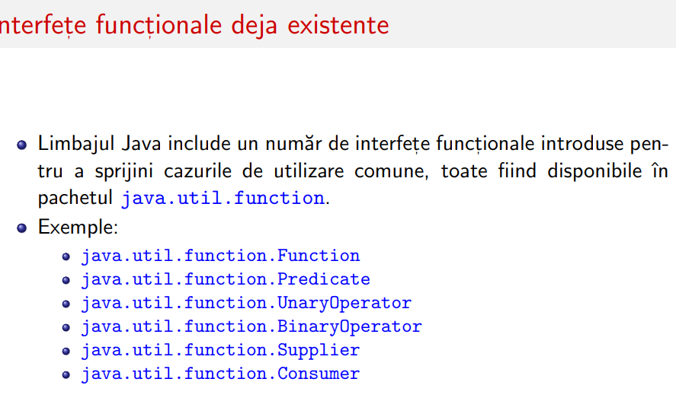



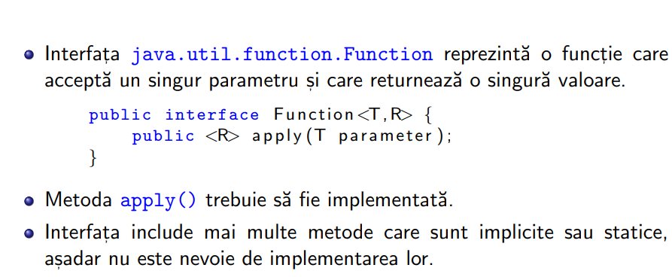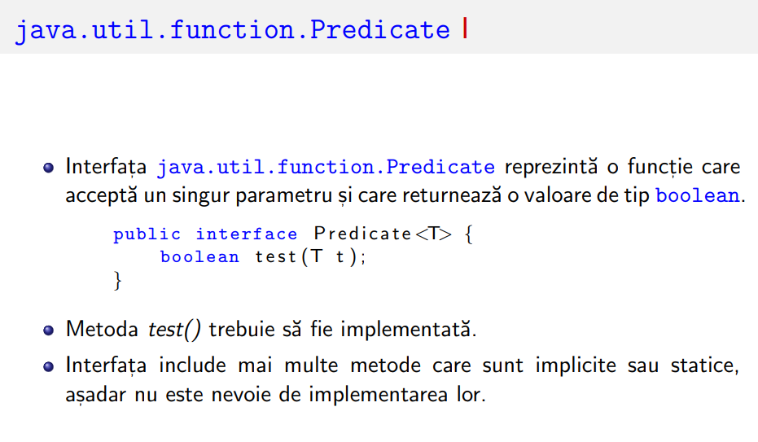



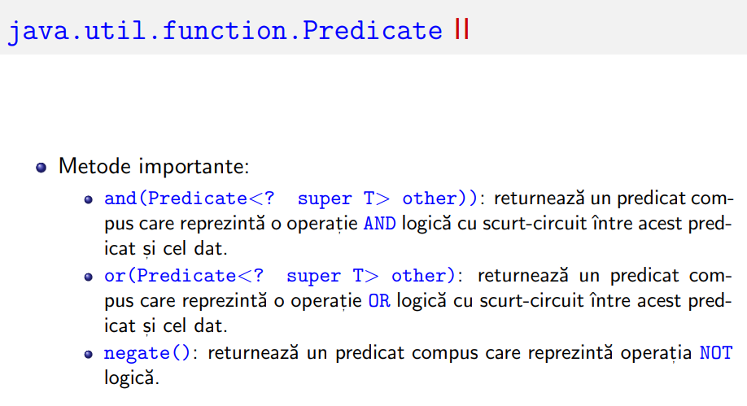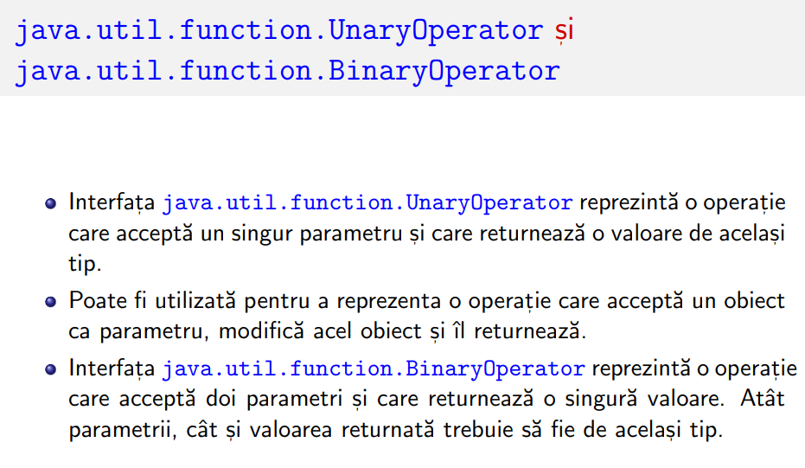



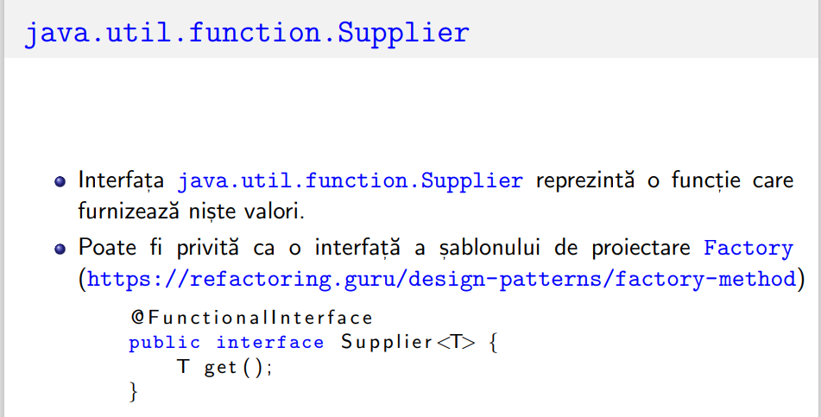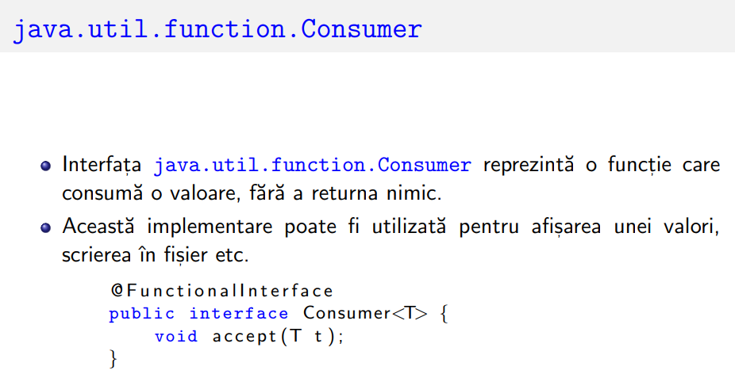



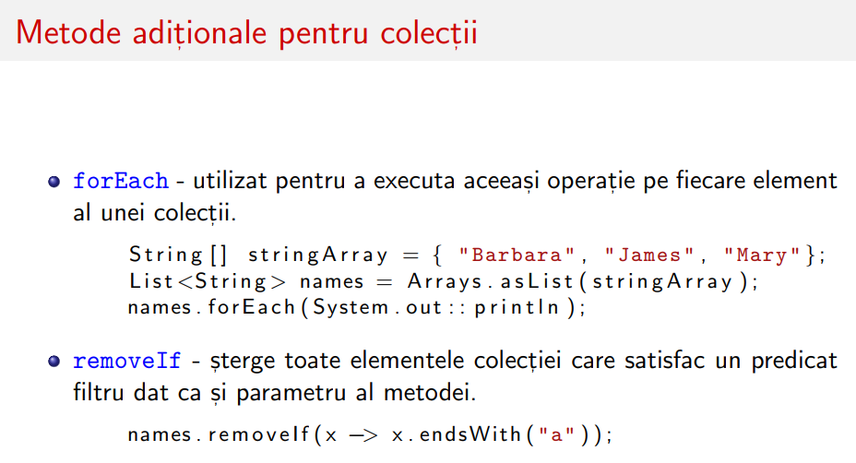



**STREAM URI**

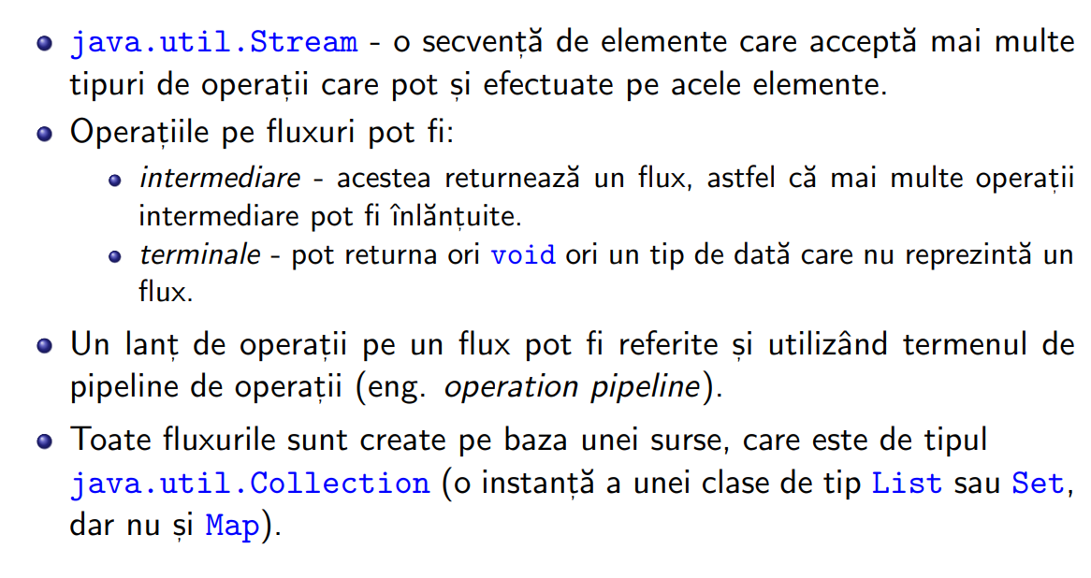



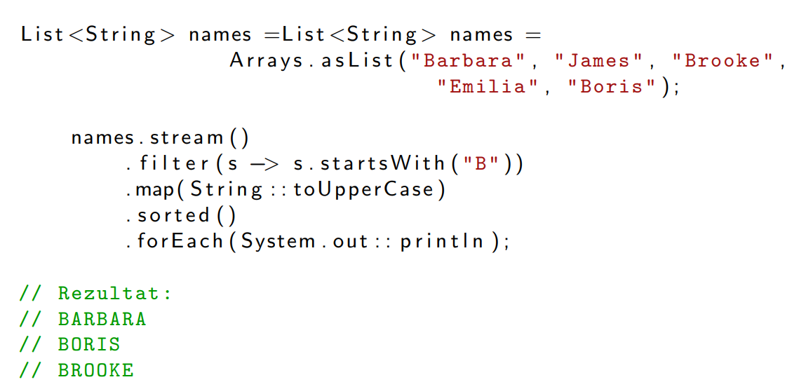



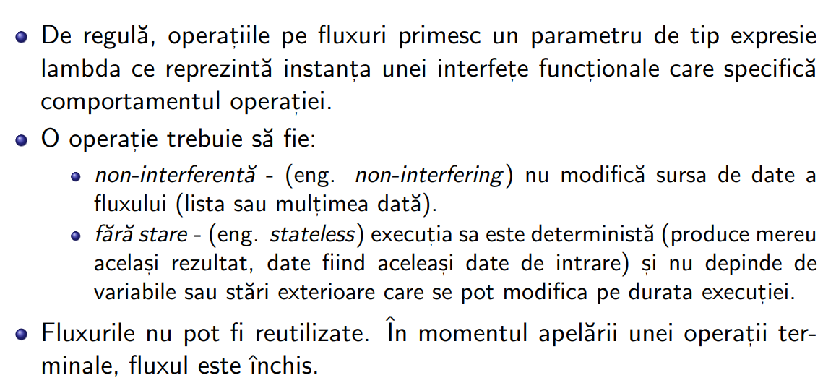



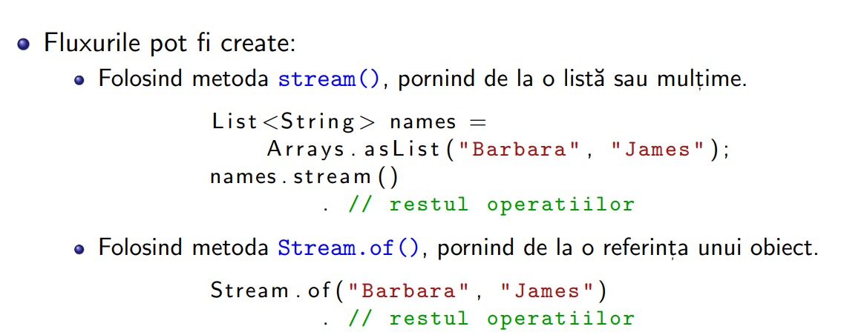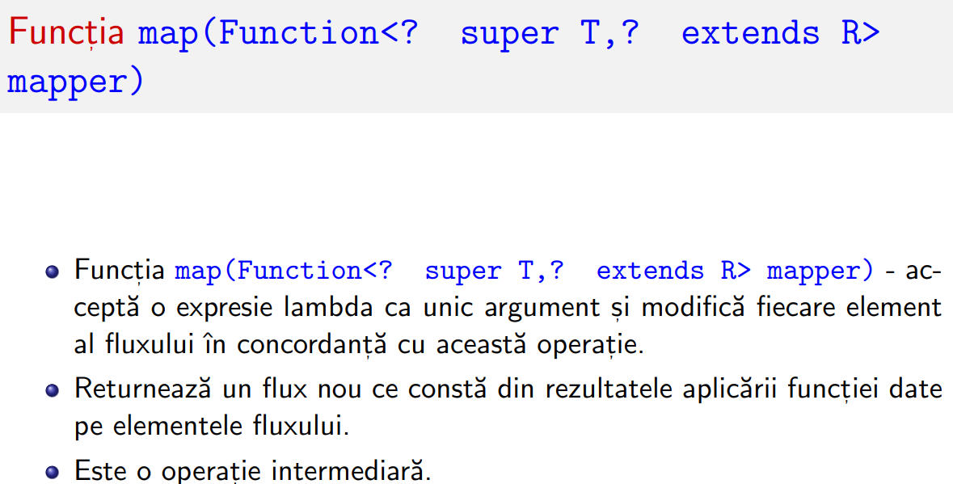



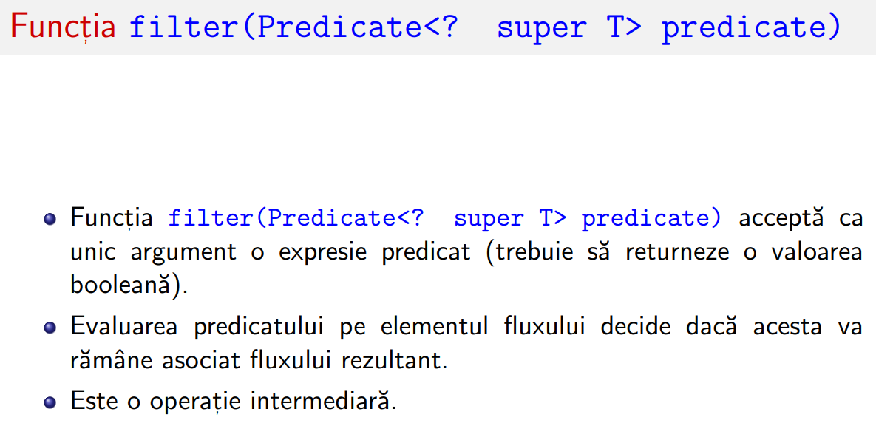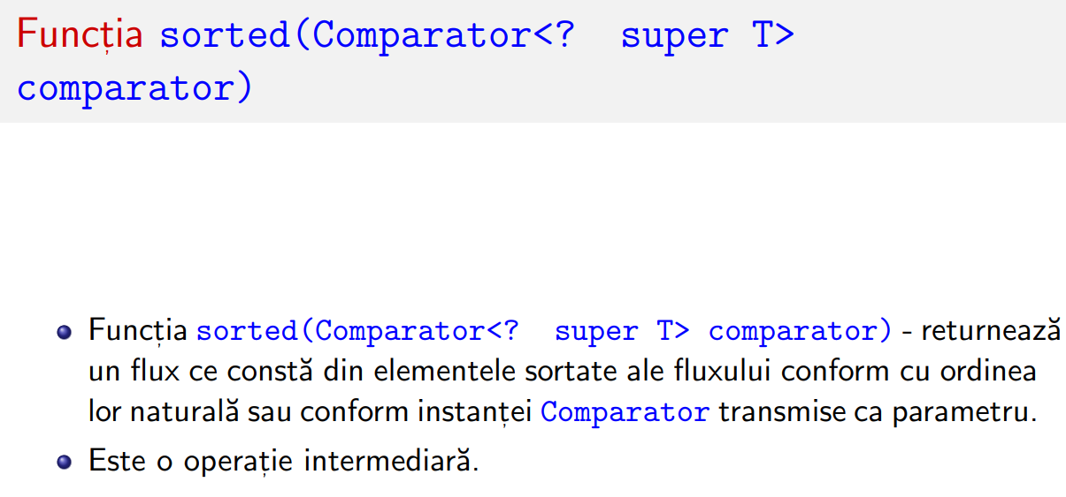



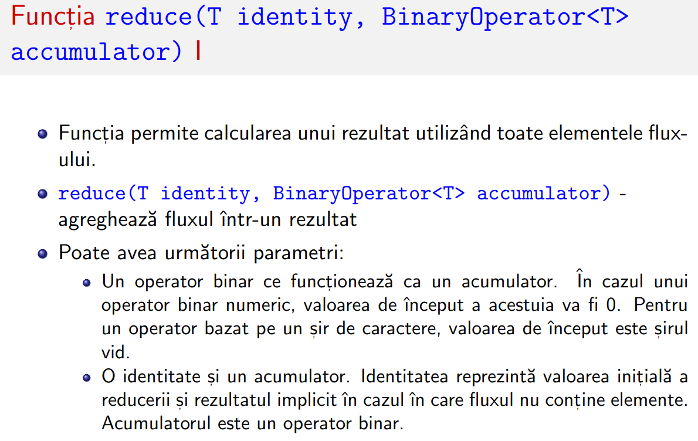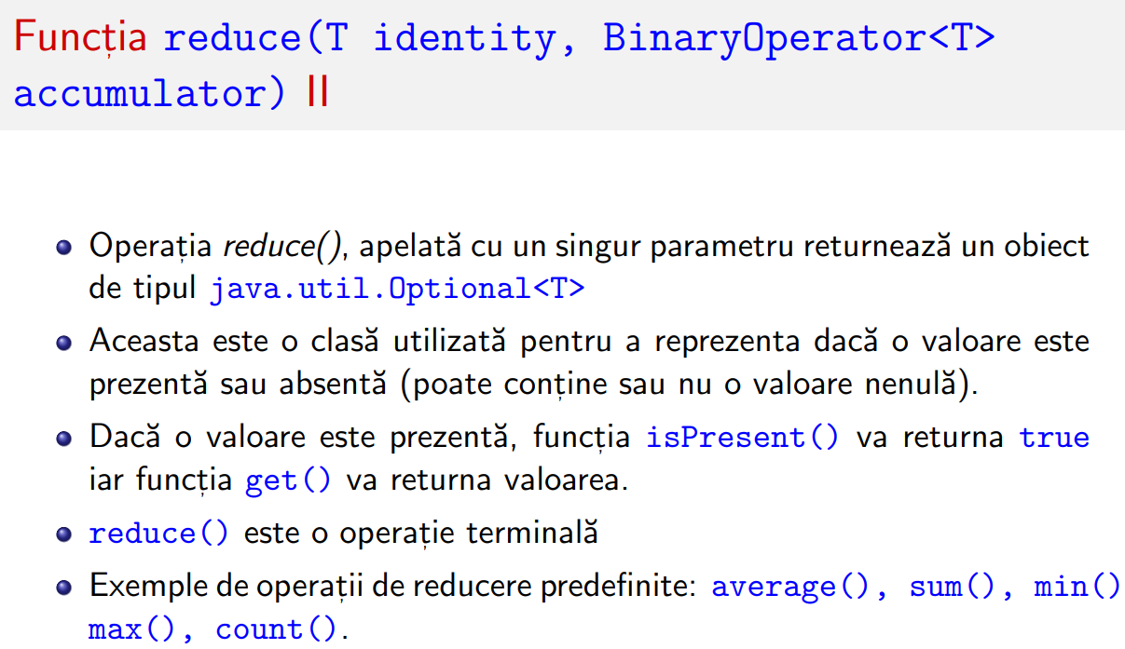



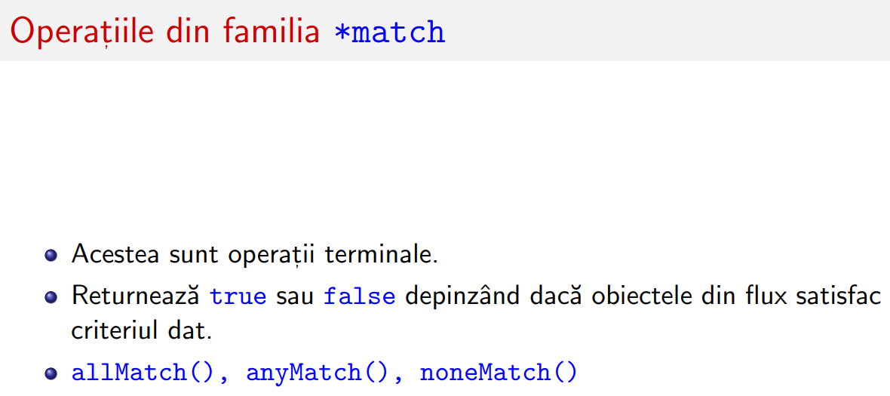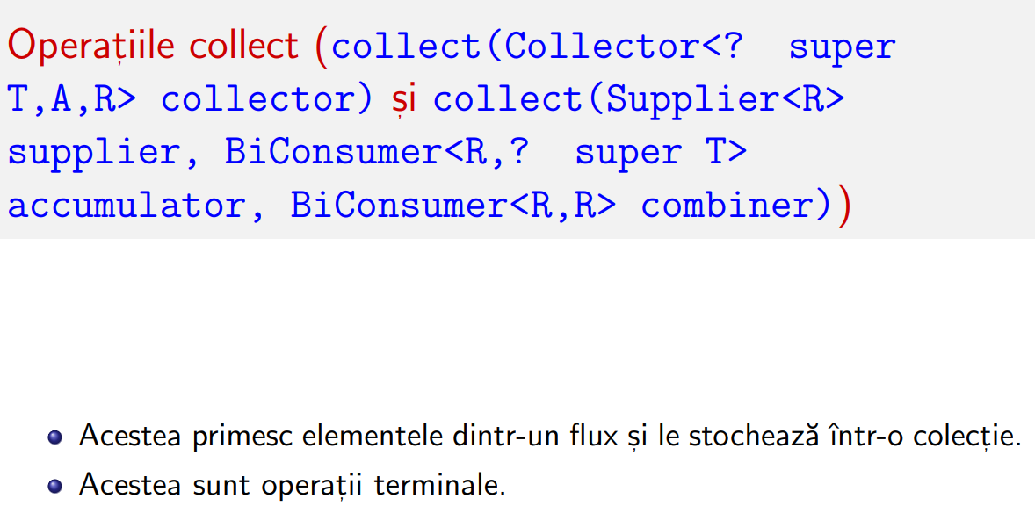



EXCEPTII

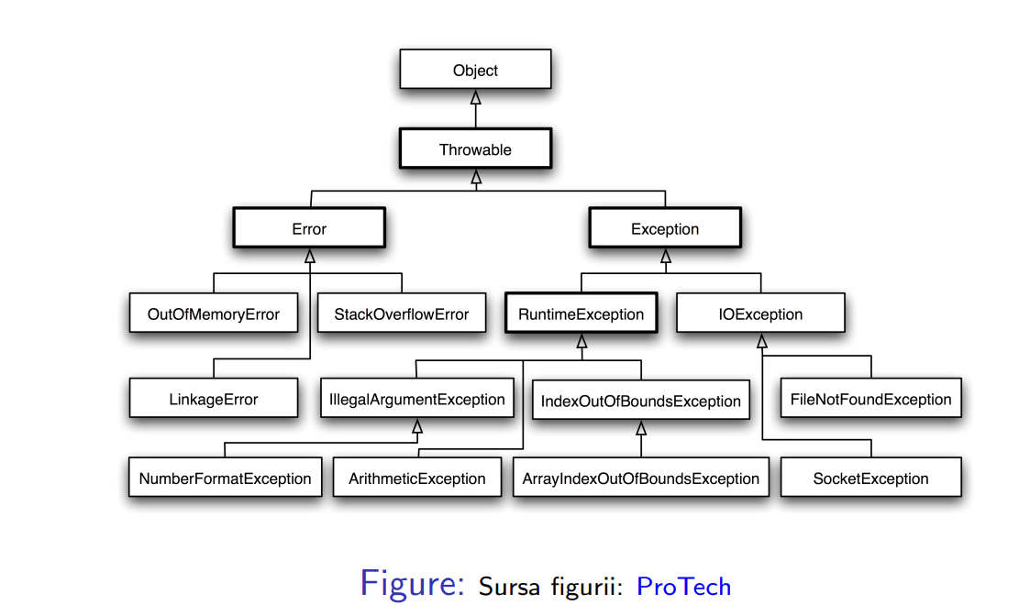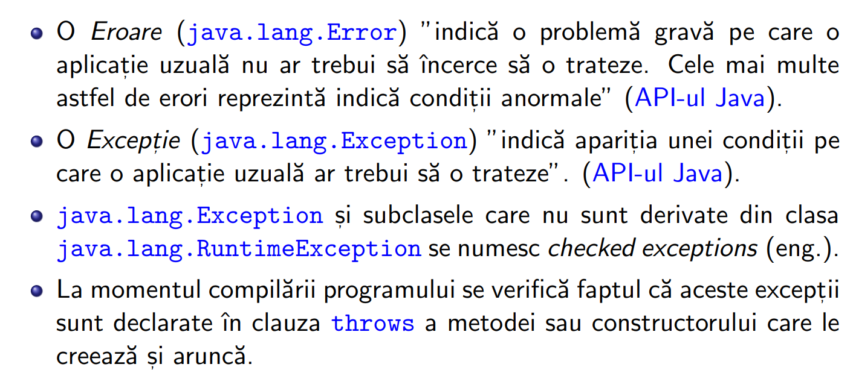



CHECKED VS UNCHEKED

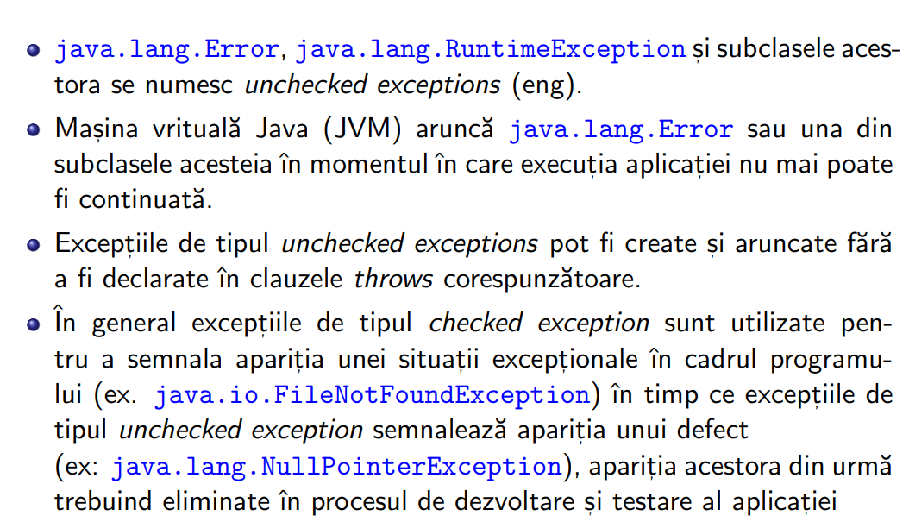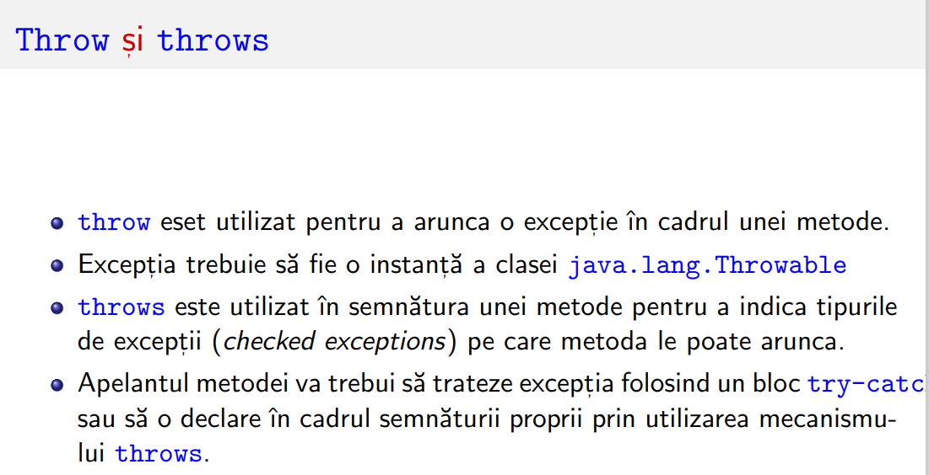

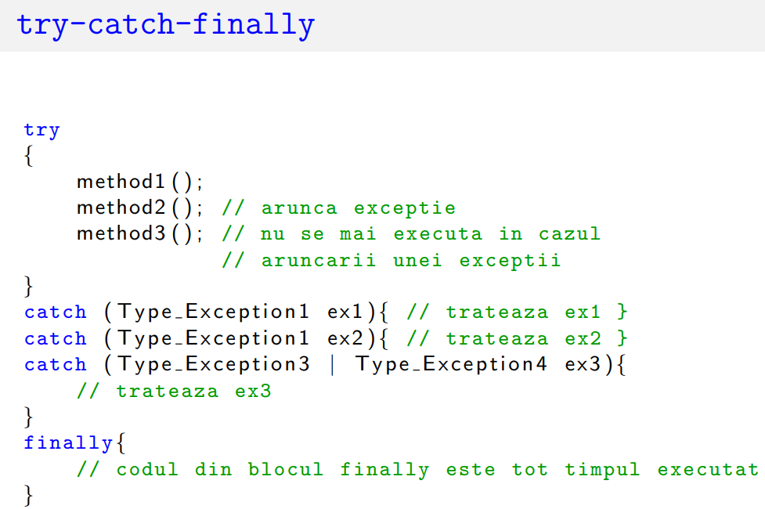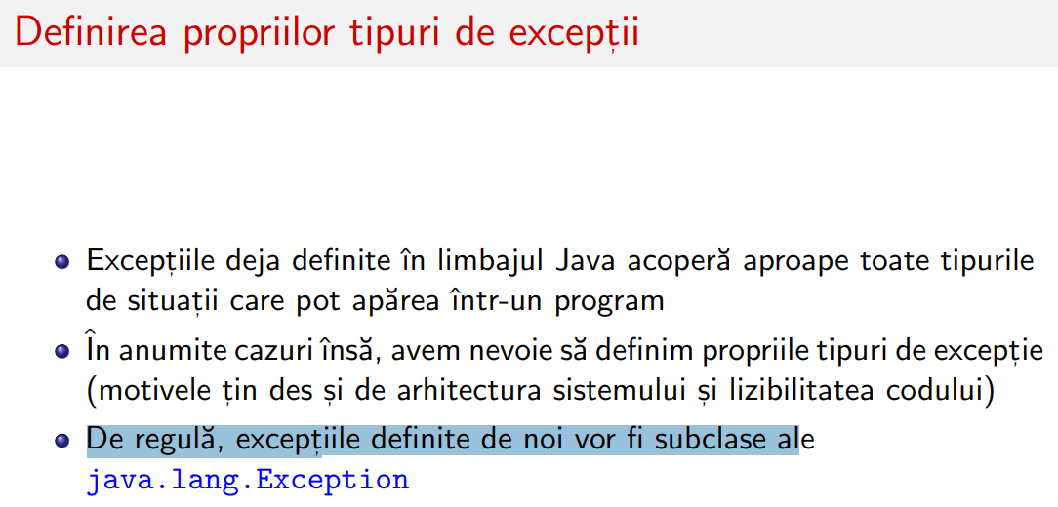

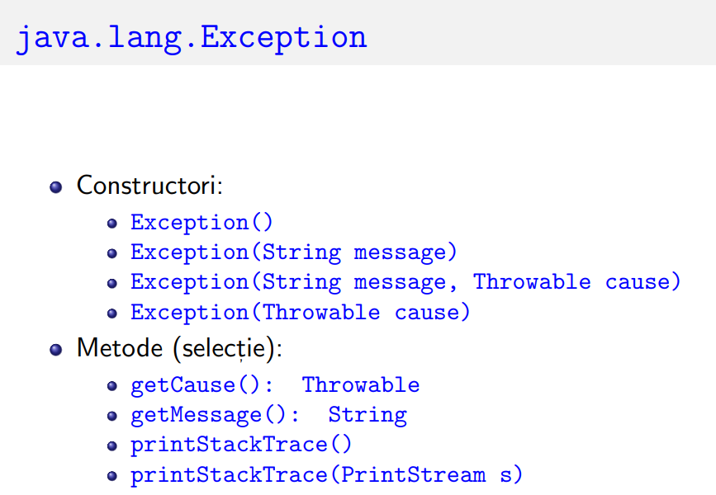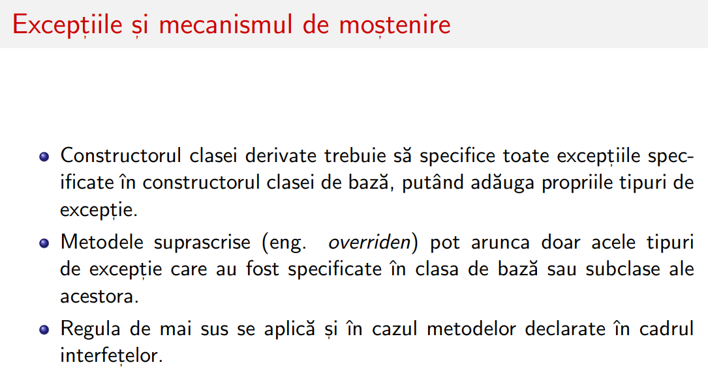



FISIERE TEXT SI BINARE

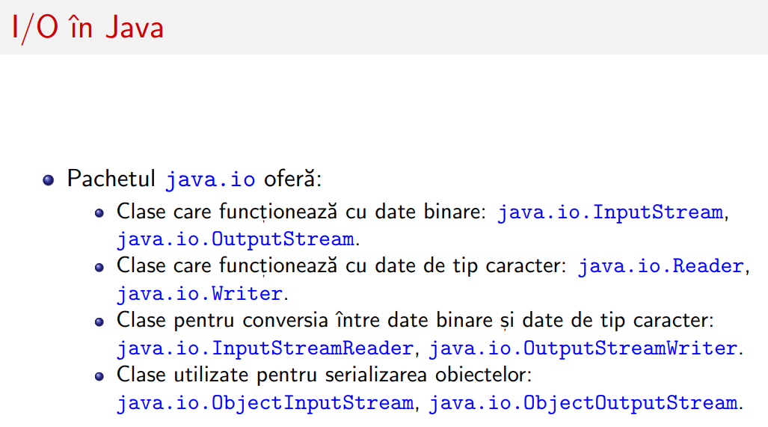

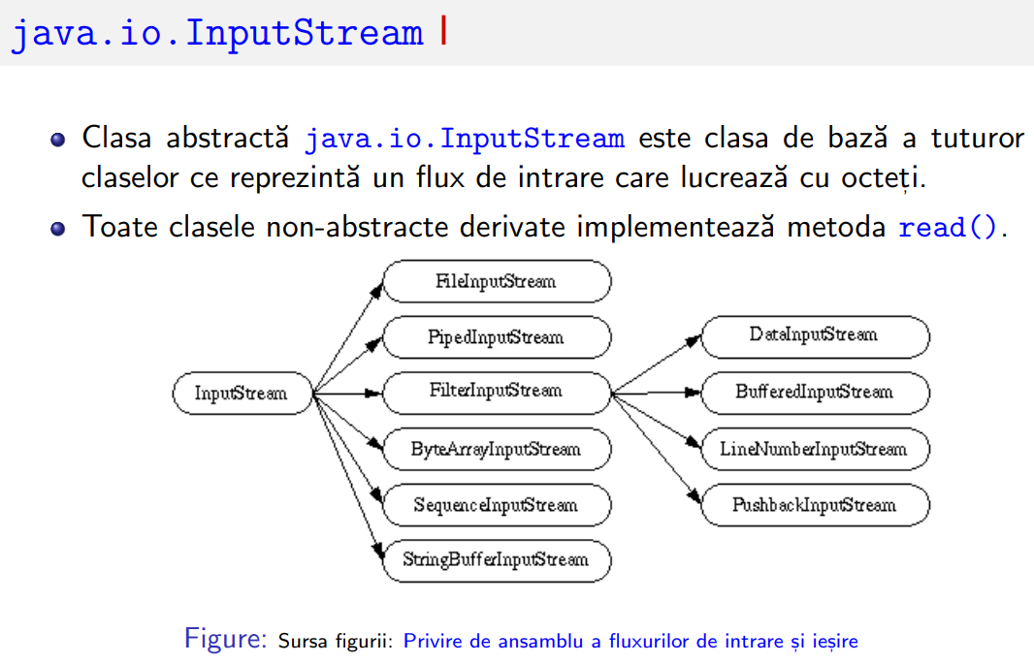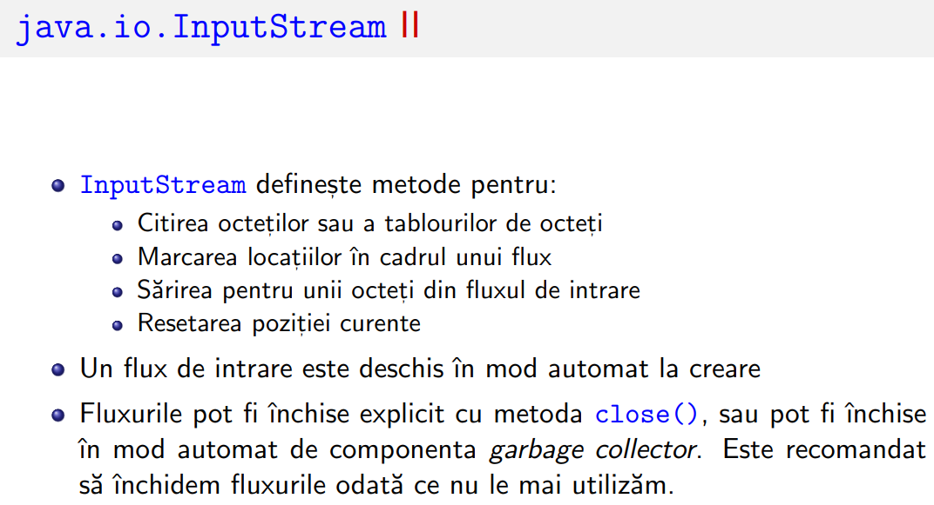

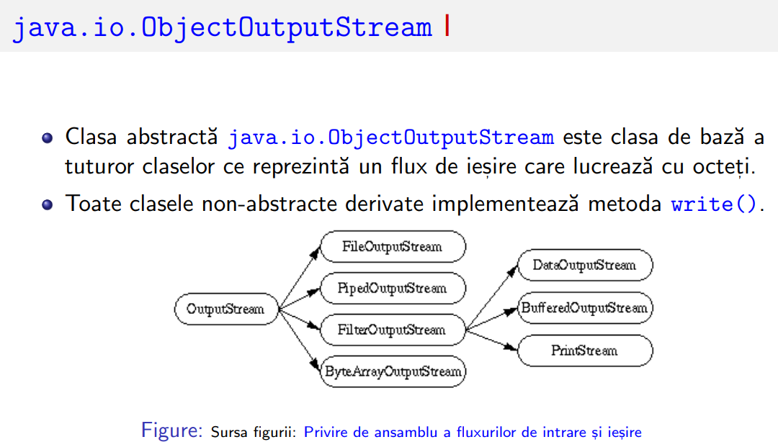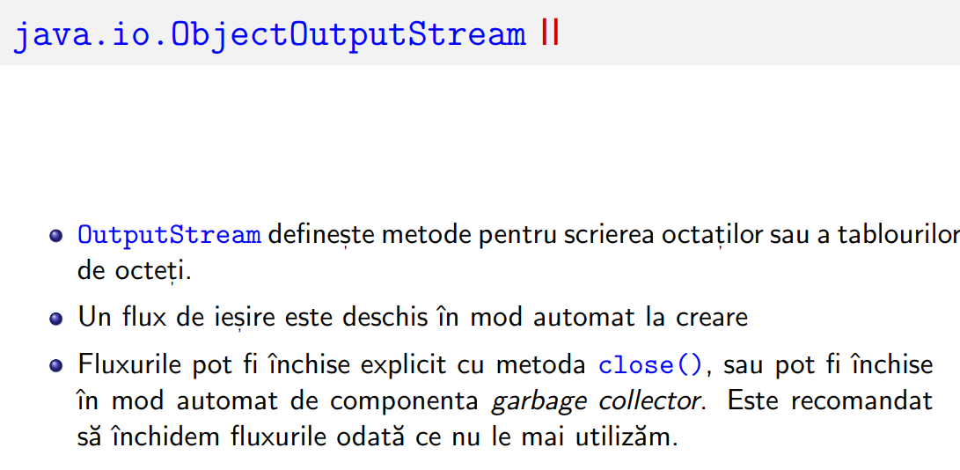

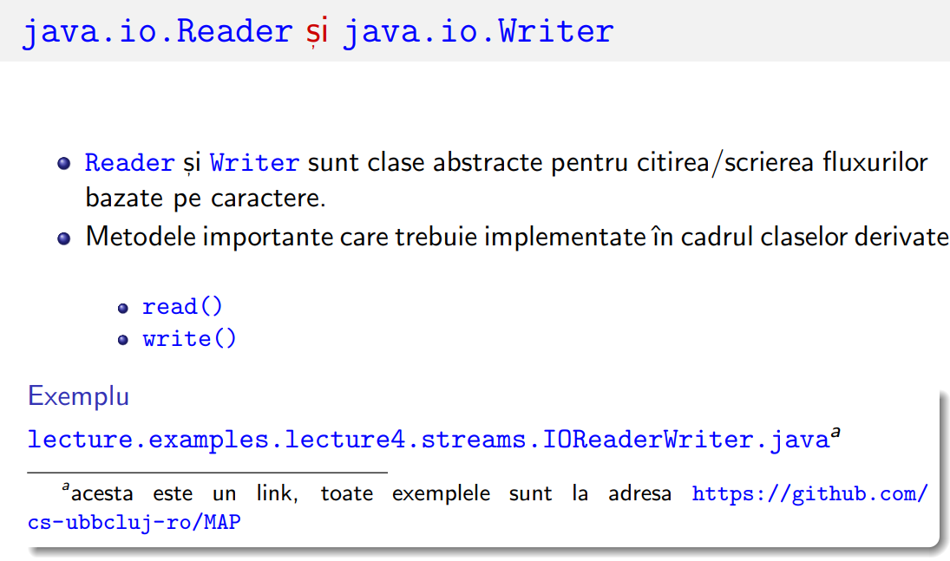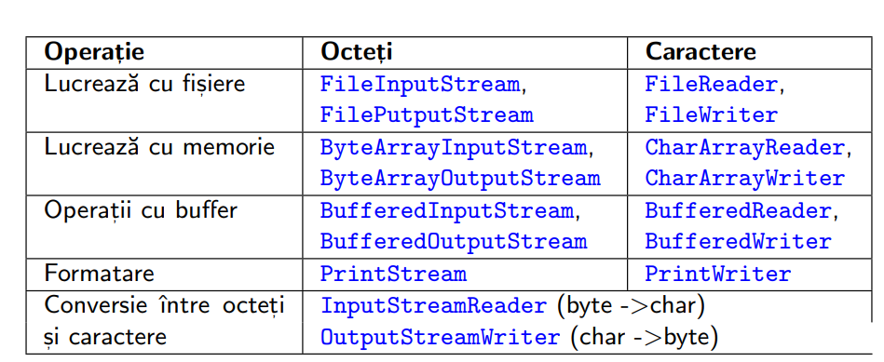

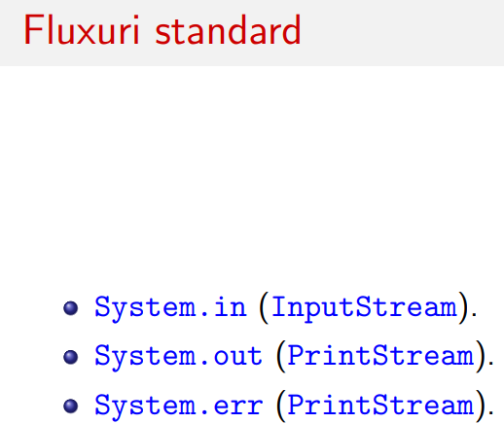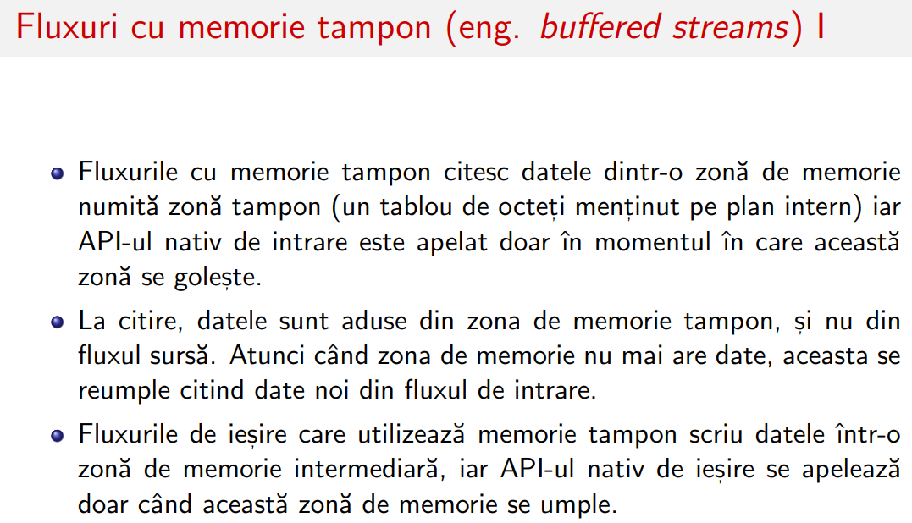

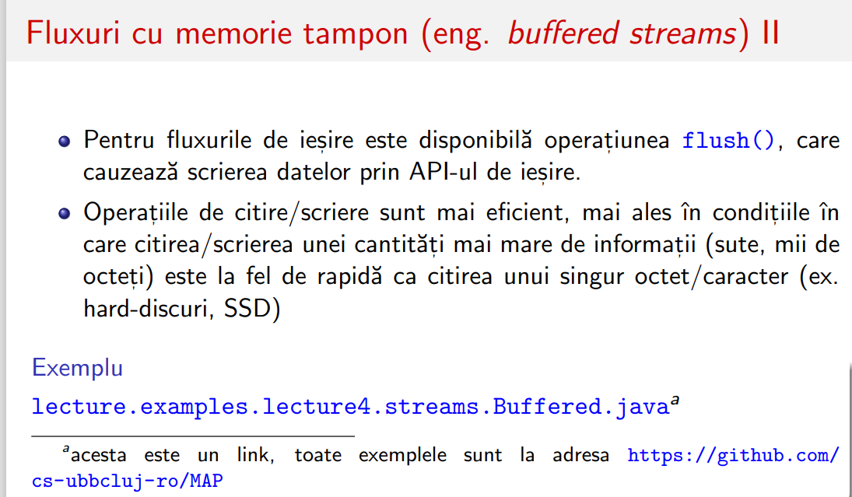

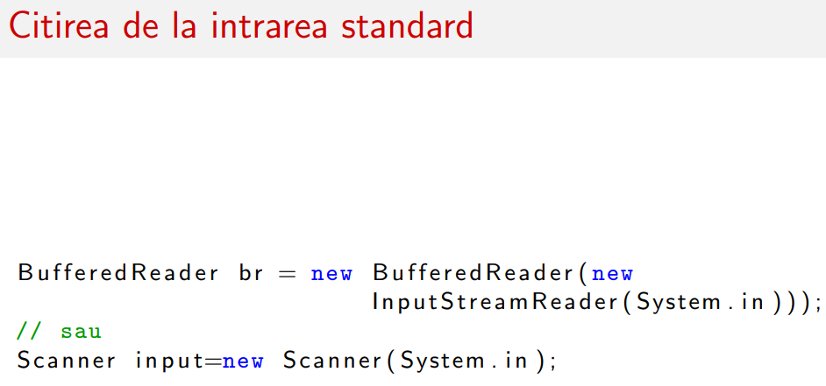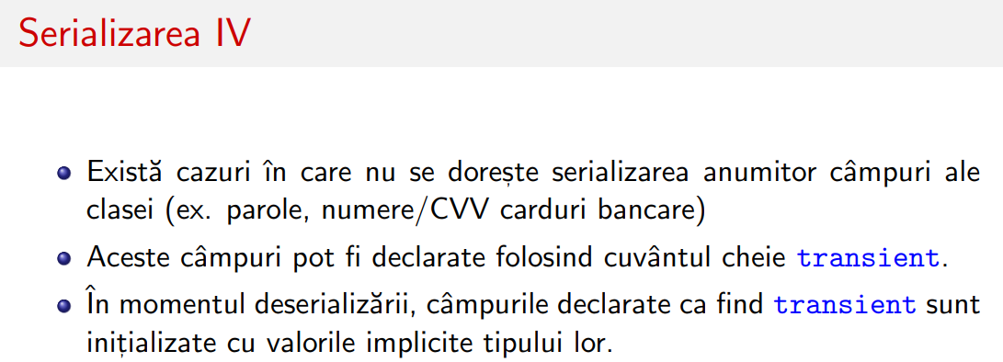

DE SCRIS TESTE LA FUNCTII

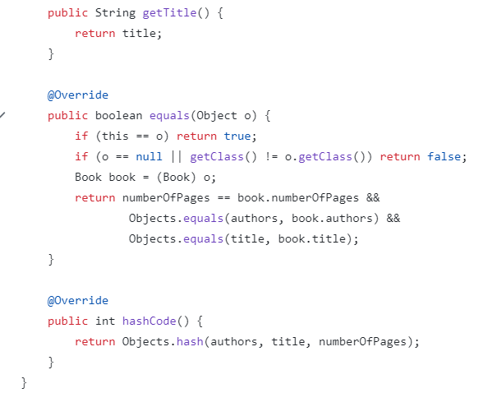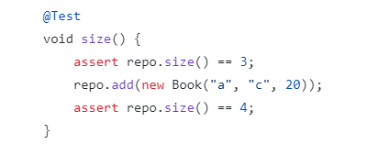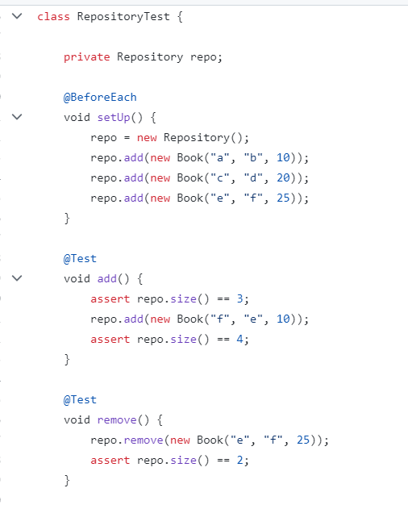

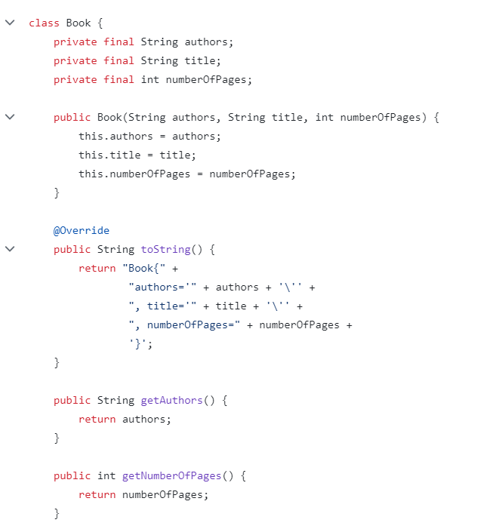

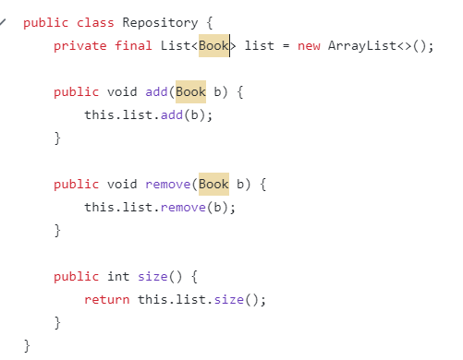



FOR EACH

VS FOR NORMAL

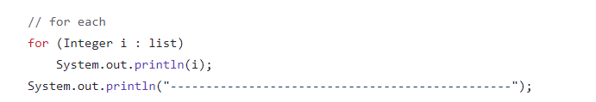

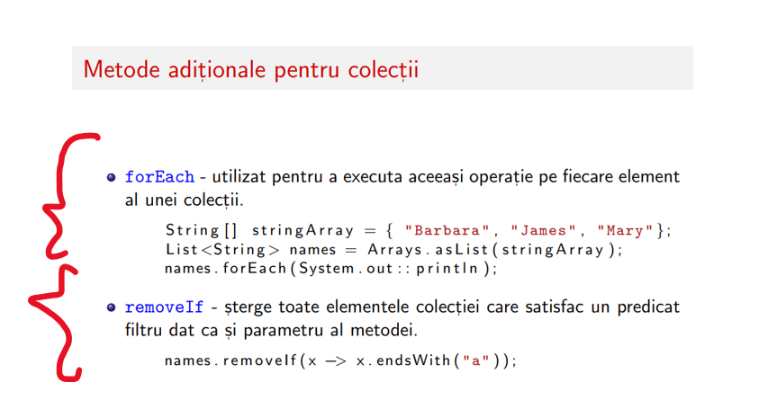

THREADS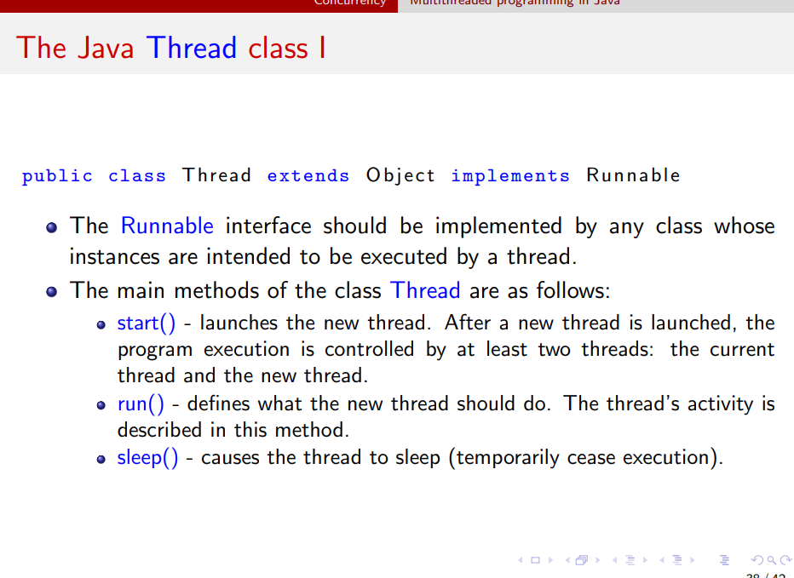



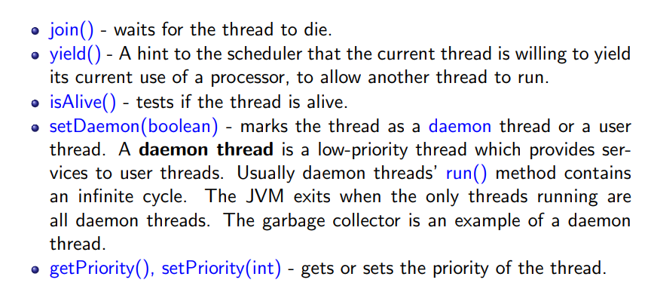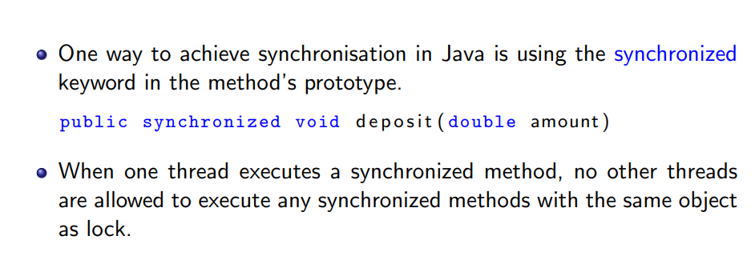



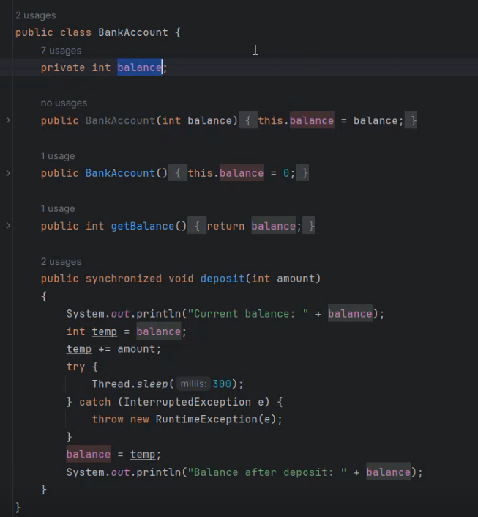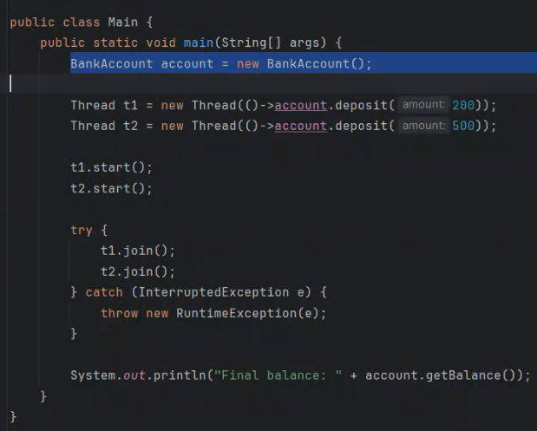

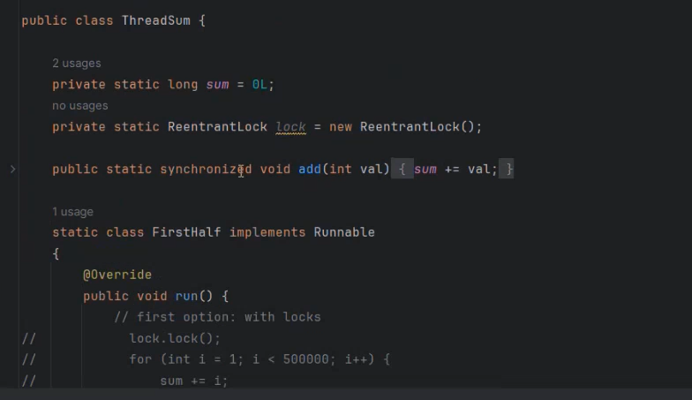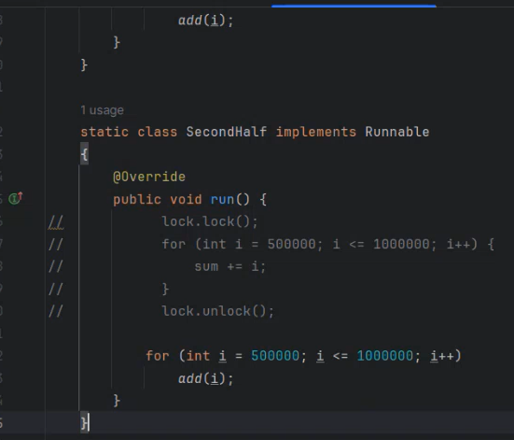

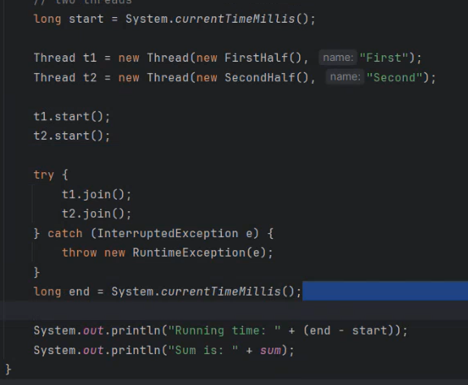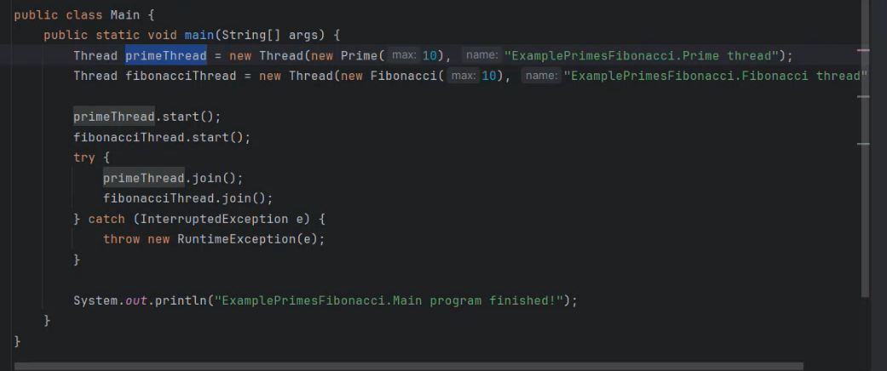

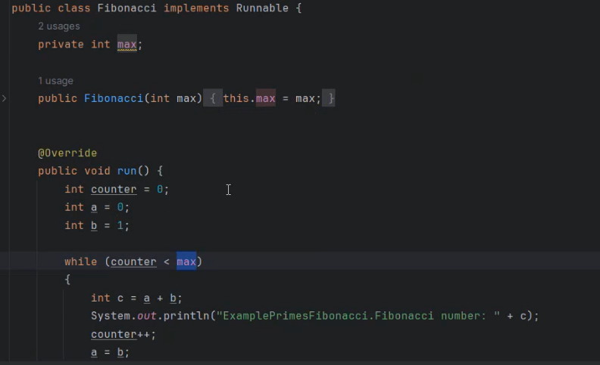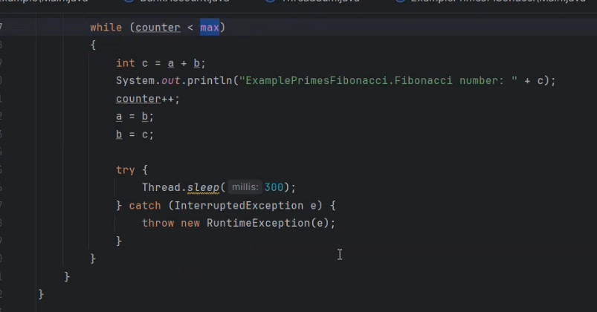

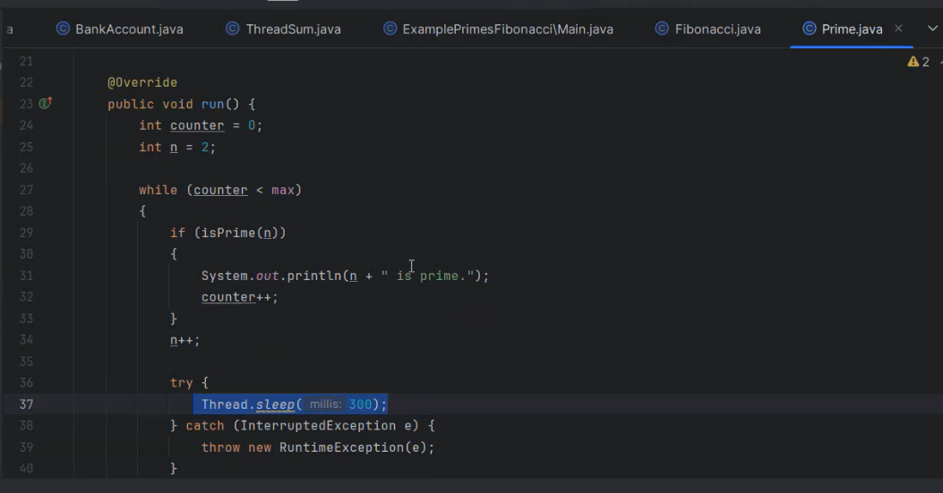public class SynchronizedMethodExample {

private int count = 0;

// Metoda sincronizată

public synchronized void increment() {

count++;

}

public static void main(String[] args) {

SynchronizedMethodExample example = new SynchronizedMethodExample();

// Firul 1

new Thread(() -> {

for (int i = 0; i < 1000; i++) {

example.increment();

}

}).start();

// Firul 2

new Thread(() -> {

for (int i = 0; i < 1000; i++) {

example.increment();

}

}).start();

try {

// Așteaptă ca ambele fire să se termine

Thread.sleep(2000);

} catch (InterruptedException e) {

e.printStackTrace();

}

// Afișează rezultatul

System.out.println("Count: " + example.count); // Output: 2000

}

}

O metoda care e final nu poate fi suprascrisa de clasele derivate  
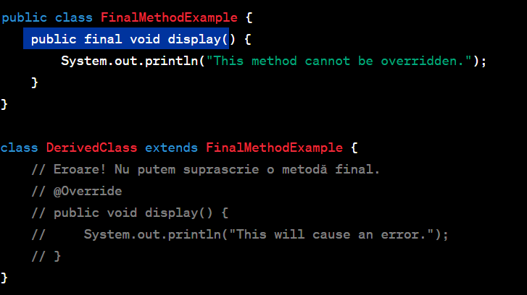



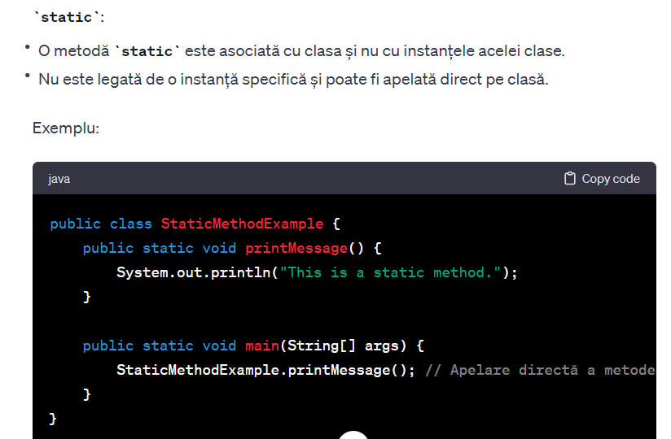



// Base class representing a pet



class Pet {

private String name;

public Pet(String name) {

this.name = name;

}



public String getName() {

return name;

}

public void feed() {

System.out.println(name + " is being fed.");

}



}

// Derived class representing a dog

class Dog extends Pet {

public Dog(String name) {

super(name);

}

public void bark() {

System.out.println(getName() + " says Woof!");

}

}

// Interface representing the sound an animal makes

interface AnimalSound {

String makeSound();

}

// Functional interface representing a sound maker

@FunctionalInterface

interface SoundMaker {

void makeSound(String sound);

}

public class PetExample {

public static void main(String[] args) {



// Example of inheritance

Pet myPet = new Pet("Fluffy");

myPet.feed();

Dog myDog = new Dog("Buddy");

myDog.feed();

myDog.bark();

// Example of using interface

AnimalSound catSound = () -> "Meow";

System.out.println("Cat says: " + catSound.makeSound());

// Example of using functional interface

SoundMaker parrotSound = sound -> System.out.println("Parrot says: " + sound);

parrotSound.makeSound("Squawk");

}

}

//

// Clasa de baza pentru persoana

class Person {

private String name;

public Person(String name) {

this.name = name;

}

public String getName() {

return name;

}

}

// Clasa Student care se extinde din clasa Person

class Student extends Person {

private double averageGrade;

public Student(String name, double averageGrade) {

super(name);

this.averageGrade = averageGrade;

}

public double getAverageGrade() {

return averageGrade;

}

}

// Interfata Validator pentru validare

interface Validator {

boolean validate(Student student);

}

// Clasa Validator1 care valideaza daca studentul are media de trecere

class Validator1 implements Validator {

@Override

public boolean validate(Student student) {

return student.getAverageGrade() >= 5.0;

}

}

// Clasa Validator2 care valideaza daca numele studentului are 5 cuvinte

class Validator2 implements Validator {

@Override

public boolean validate(Student student) {

String[] words = student.getName().split("\\s+");

return words.length == 5;

}

}

public class ValidatorExample {

public static void main(String[] args) {

// Crearea unui student

Student student = new Student("John Doe", 7.5);

// Crearea validatorilor

Validator validator1 = new Validator1();

Validator validator2 = new Validator2();

// Validarea studentului

boolean isValid1 = validator1.validate(student);

boolean isValid2 = validator2.validate(student);

// Afisarea rezultatului validarii

System.out.println("Validator1: Student is valid - " + isValid1);

System.out.println("Validator2: Student is valid - " + isValid2);

}

} 